**CREATE A MULTI-PAGE RESPONSIVE**

**WEBSITE**

**A PROJECT REPORT**

In partial fulfilment of the requirements for the award of the degree

***BACHELOR OF TECHNOLOGY***

***IN***

***COMPUTER SCIENCE AND ENGINEERING***

***BY***

***PRITAM KABIRAJ***

***AND***

***SOUHARDYA GAYEN***



***NEOTIA INSTITUTE OF TECHNOLOGY***,

***MANAGEMENT AND SCIENCE***

***KOLKATA, WEST-BENGAL, INDIA***

In association with



***EXPOSYS DATA LABS***

**CONTENTS: -**

ABSTRACT

1) Introduction

2)Four Fundamental Principles of RWD

2.1) **Fluid (Flexible) Grids**

2.2) **Flexible (Scalable) Media**

2.3) **Media Queries**

2.4) **Dynamic Content**

3)Popular Responsive Web Design Frameworks

3.1) **Bootstrap**

3.2) **Skeleton**

3.3) **Foundation**

4)Tests to Check Responsiveness of a Website

4.1) **Google Mobile-Friendly Test**

4.2) **Browser Window Resizing Trick**

4.3) **Mozilla Firefox and Google Chrome Built-in Responsive Tests**

4.4) **Remote Testing Resources**

5) Responsive Web Design in Future

6) Proposed Methodology

7) Architecture

8) Implementation

9) Conclusion

References

**Abstract.** Today’s extra smile devices i.e. mobile phones, smartphones; small devices i.e. tablets, mini laptops; medium devices like laptops, desktops; and large devices like new age TVs, LEDs, and projector screens capable of accessing websites have changed the approach towards website design and development. These high-tech devices and gadgets have placed the web designers and developers to serious issues of user experience and accessibility. Thanks to Ethan Marcotte for inventing the technique of Responsive Web Design by which developers can now produce device agnostic websites which respond, with respect to their layout and content presentation, on all kinds of device resolutions without requiring any special modifications. This means a single Responsive Website is now sufficient to serve all device sizes. But being device agnostic is only the first milestone towards responsiveness. This monograph discusses the factors that reasoned the Responsive Web Design (RWD). RWD is discussed in detail with respect to present scope and finally a debate is presented on future trends in RWD, and proposed future enhancements which show how responsiveness can be further extended to meet with complete user needs in the light of content and context.

**Keywords:** diverse mobile devices, responsive web design, device agnostic website, ubiquitous web, responsive philosophy, context responsive websites.

## 1 Introduction

Web Browsers are enhancing on a very fast pace. Every day we confront a large number of new devices categorized as extra small, small, medium and large devices. These devices, apart from size, accompany a diverse range of configurations and physical characteristics like we have devices with different resolutions, pixel density, touch screen controls, track-pads and keyboards or a combination of these. Technology may be advancing at a rapid pace but it doesn’t make any sense that one should keep exchanging the old devices at that pace. All new inventions need to be backward-compatible with existing technologies thus allowing people to continue using older implementations on new devices. There might be situations when a newly released device or browser is canceled a few weeks later after its release. Hence, what is true today may not be true tomorrow and resultantly all this leads the users in a situation of chaos.

But this is only one side of picture. On the other hand, chaos leads to innovation and creativity. Quite often sitting in waiting area of an airport or a bus terminal you would see people using different size of mobile devices. You will observe that there might be some 20 to 40 people in a particular waiting area but will be surprised to see every person using a mobile device of different size, configuration and make. Put an eye on the gadgets of the people sitting nearest to you and you will see most of them browsing different websites of news, articles, or social networks. During journey people love to interact with their mobile gadgets for hours long till they reach their destination. Then there comes into play the numbers game. A person usually holds more than one mobile device i.e. a smartphone, tablet device, laptop, etc. simultaneously.

Table-1 shows active number of cellular subscribers worldwide[1]in both developed and developing countries for the years 2008, 2011 and 2014 [1]. Table-2 presents active number of mobile broadband users worldwide1 also in developed and developing countries for same three years [1] . Figures in these tables reveal that the number of cellular subscribers is about to reach total number of people on earth. Similarly, the number of mobile broadband users is increasing exponentially especially in developing countries. These growing numbers of cellular subscribers and mobile broadband users with varying display sizes, configurations, networks speeds, etc. has placed the website developers in a situation of disruption. Formerly, website developers have been successful in dealing with mobile devices by offering separate sites for different kinds of devices, and this approach being known as Adaptive Website Design. This means having differ-

**Table 1.** Number of active cellular subscribers worldwide (in millions)

|  |  |  |  |
| --- | --- | --- | --- |
| Countries and Year | 2008 | 2011 | 2014 |
| Developed | 1250 | 1300 | 1400 |
| Developing | 2750 | 4600 | 5600 |
| **Total** | **4000** | **5900** | **7000** |

ent websites for desktop, tablet, touch-input mobile device, and a simpler mobile device without touch support i.e.at least 4 different websites for one company. This approach completely depends upon the business objectives, the users, and

**Table 2.** Number of active mobile broadband users worldwide (in millions)

|  |  |  |  |
| --- | --- | --- | --- |
| Countries and Year | 2008 | 2011 | 2014 |
| Developed | 337.60 | 720 | 1035 |
| Developing | 84.40 | 480 | 1265 |
| **Total** | **422** | **1200** | **2300** |

capabilities of a specific project. This approach has merits as well to personalize the sites, both in content and behavior, thus making it easier to customize the user experience considerably. But this approach does not balance in a good form i.e. the four websites that need to be tested, updated and maintained will require as many resources then. This approach do not appear feasible as a certain number of developers and other resources multiplied by number of website versions required would involve huge time and money. Continuously rapid evolving technology; decreasing prices of smartphones, tablets, desktops and laptops; diversity in primary specifications of these devices of different manufacturers and also amongst devices of the same manufacturers, has worsened the situation of chaos to a greater extent. Consequently, if we continue with Adaptive Web Design approach today we would certainly end up with our websites no longer accessible on new and upcoming devices.

It might be possible that a company completely denies to cater to the needs of mobile device users and adopts the fixed-width layout approach. A website built using fixed-width layout has width and height of components in fixed pixel units. No matter what screen resolution a visitor has, the same amount of width and height will be presented to that particular user. Whenever such a website is viewed on mobile devices, the user will certainly end up in pinching, zooming and scrolling in both vertical and horizontal directions, and may face slower page load times.

A better solution to the above problem would be to develop a single website using principles of Responsive Web Design to make it available on devices of all resolutions that exist today and is also future-ready. *Responsive Web Design is a set of tools and techniques used together to build a single rich user-interface website which is equally accessible on devices of various sizes and resolutions, and to user of all network bandwidths no matter high or low.* [2].

A web designer Ethan Marcotte first coined the term Responsive Web Design (RWD) in May, 2010 in his article “Responsive Web Design” [3]. His approach to design websites using techniques of RWD instigated revolution in the discipline of web design. He simply used three existing CSS3 tools: i) media queries, ii) fluid (flexible) grids, and iii) flexible images to create a responsive website

(http://goo.gl/I1T8mL) that displayed on devices with different resolutions correctly. Subsequently people started exploring the RWD techniques and lead-

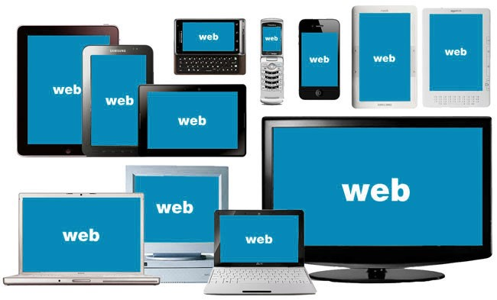

**Fig.1.** Making the Web available on various device sizes (Source:

cdotnetinfosystem.com)

ing content publishers rebuilt their websites using this new stunning model of RWD. Many popular websites publishing articles, blogs, and news started discussing the RWD and they declared 2013 as the year of Responsive Web Design [4], [5].

In this age of technology we see things evolving continuously at a very rapid pace. So being able to develop deice agnostic websites, i.e. a website which can be viewed on all kinds of devices without regard to their size/ dimensions or other characteristics, is only the first milestone achieved by web designers. We need to serve users with websites which are context responsive and adopt more responsive philosophy. That is a website would be able to present whatever content is suitable for a user with respect to his preferences, location, age, and culture. And that website would be called a context responsive website which will be both viewable on all kinds of device types and by all kinds of users w.r.t. their behavior and contexts.

## 2 Four Fundamental Principles of RWD

Responsive Web Design is a newfound technique but it has evolved rapidly. By simply applying CSS rules inside media queries is not enough to cope up with the responsiveness. In this section an explanation of four underlying principles of RWD is presented to enhance readers’ understanding regarding fundamentals building blocks of RWD.

### 2.1 Fluid (Flexible) Grids

In the realm of web, a grid is simply a collection of rows and columns. A grid is used to organize layout in a web [2]. In a grid, row consists of one, two or more columns. Each row, no more than maximum number of columns, could span one, two or more columns. Content is then placed inside columns. Grids help to add order and creativity in the website by organizing the content in a uniform way so that whenever new content is added it looks consistent with the overall presentation of the website. Before the advent of RWD’s fluid grids, fixed-width grids using pixel measurements have been used which posed the drawbacks of pinching and zooming of the content whenever viewed on smaller displays. Figure-2 shows a, fixed-width, 960px grid of two columns. The width of context is 960px. The top row (of 880px) of the container spans two columns followed by another row of two columns of 640px and 220px. The space between the rows and columns is the margin property referred to as gutter width in RWD. The easy first step in creating a fluid grid layout is to first make a blueprint of the desired fixedwidth layout. Figure-2 is a sample such blueprint. Then we need to calculate proportions of the elements in percentages. In a fluid grid, width of all elements starting from parent container, then header, and all the way to a footer section is stated in relative units e.g. percentage, rem, em, etc. An “em” is a relative CSS unit for expressing length values relative to font-size of immediate parent of an element [6]. By default 1 em is equal to 16px. A value of 2 em means 32px. Em is used to express the values of inner level elements inside columns. Similarly, ‘rem’ is used to express length values relative to root (html) font-size. Value of 2 rem means 2 times the font-size of the root element. To design a fluid grid layout we also use values in percentages. Formula to calculate proportions of the design in percentages is as below:

(target / context) x 100 = desired value % (result rounded to 0 decimal place)

Target is the width of an element in fixed-width pixels. Context is known as the width of the environment in pixels for which the layout is required. Row is also called a wrapper because it contains columns inside it which then contain our elements. A wrapper in meaning here is very much similar to a toffee wrapper which wraps around the toffee. Once we have calculated the wrapper value, then for onward calculations this wrapper value will be used as context value. In figure-2, context is 960px and wrapper width is 880px. Following relative values are calculated for this context based on the above formula:

* Container Width: (960px / 960px) x 100 will correspond to 100% container width
* First Row (spans two columns): (880px / 960px) x 100 = 92% (this values will also be used for wrapper)
* Second Row Left Column: (640px / 880px[2] ) x 100 = 73%

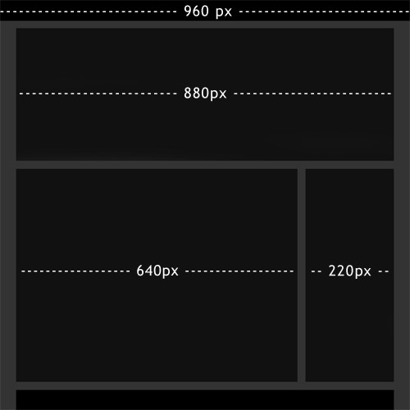

**Fig.2.** Fixed-width 960px grid (Source: http://www.smashingmagazine.com)

* Second Row Right Column: (220px / 880px) x 100 = 25%

The above discussion is enough to understand a fluid grid. In practical situations, things are more complex because we have to consider a device size context ranging from extra small devices (less than 480px) e.g. small smartphones to larger devices (greater than 1200px) e.g. large desktops/ laptops, smart TVs, etc. and we need to calculate values of all the required elements in relative units for all targeted context widths.

### 2.2 Flexible (Scalable) Media

Media (images and videos) content is a source to provide pleasing and richer user experience. But using excessive media could result in slow load times for a website. When it comes to smaller devices the situation needs more attention as these devices have little resources in terms of network bandwidth and browser capabilities. To maintain aspect ratio of the media on various device densities is another challenge. Like an image would appear crisp and sharp on a particular device size but it would become blurry and lost its pixels when opened on a large display or on a device of same size but greater density. The website performance greatly depends on how beautifully the developer has programmed to display images and videos. “GlobalDots” study shows that a greater number of users would leave a web page if it takes more than 6 seconds to load [7].

There are three types of media which need to be tackled with great amount of care in responsive paradigm and that is i) video, ii) images (foreground), and iii) background images.

To make flexible/ scalable media we need to write rules in CSS, HTML and/or JavaScript. There are a lot of pre-coded packages available on internet ready for usage so in this monograph we’ll not cover the coding part rather this study focuses on key underlying concepts. The key idea to make responsive media is that we do not use fixed-width height for images and videos instead this value is set to auto or not provided at all. We first create a container with proportion width size to hold our media and it is then sized to some percentage of the container. Container of media inherits its width from the outer container and the media inherits its width with respect to that of its container. For example, we want to make image xyz.jpg responsive. We’ll first create a container of some 50% width. We then place our xyz.jpg image inside that container and set the width to say 100% so that at whatever device size the image is opened the image will resize itself to fit in the container and container will get its width from device width in some percentage accordingly. Density means the ratio of CSS pixels to device pixels. If we proram a 100px by 100px image to be viewed on a device with 1:1 ration then it will work fine but if that same image is opened on a device with pixel density of 2 (i.e. 1:2 ratio) it would mean that the image will become 200px wide and 200px high, and consequently it will lost its resolution. Conversly, if a high density image is viewed on a device with low density then the image will become blurry. Moreover, we also need to take care of grids, columns, and rows here. Each and every content part either an image or a text block is specified in a column or more with respect to context i.e. device size. The situation will become clear when we’ll study Media Queries in section

2.3.

### 2.3 Media Queries

A great user experience benefit of responsive design sits in lesser amount of scrolling and resizing. That is a user of the responsive website will not be pinching or zooming, and scrolling in horizontal direction. Thus only vertical scrolling is required to surf a responsive website irrespective of whether the device in use is a smartphone, tablet, desktop computer or a smart-TV. Here comes in the need of media queries which contain CSS style rules to apply to the values of width, height, depth, color, resolution, margins, padding, etc. when a specific viewport size is encountered.

**Viewport.** This is simply the visible area of the browser i.e. the browser width in pixels. The concept seems to be all simple apparently but there are actually two types of pixels: device or hardware pixels and CSS pixels. Device pixels are the unit of design that form the basis of everything we make on a device [8]. A device screen which is 1280px wide means that a maximum of two elements of 640px width or four elements of 320px width can fit side-by-side at once on the screen. CSS pixels have nothing to do with the screen. CSS pixels means everything visible inside the browser window. On normal devices, 1 CSS pixel corresponds to 1 device pixel but on devices with high pixel density 1 CSS pixel may correspond to more hardware pixels. *Pixel Density* is the number of pixels per inch (PPI) that can be displayed in a physical display [9]. This means that CSS pixels may not correlate with the device pixels. CSS pixels change with the zoom in or out of a page. For example if a user zooms in a page to 150% then CSS pixels will increase by half time the width and height of elements. If the user zooms out a page to 50% then CSS pixels will reduce to half the width and height of elements but device pixels never change by zooming in or out or by any other means.

Due to variable nature of CSS pixels and constant device pixels of varying density, we have to take into account the viewport considerations. viewport is a responsive meta-tag of HTML to control layout of web pages. Again, we have two viewports here: the visual viewport and layout viewport. Layout viewport corresponds to device pixels and visual viewport is the portion of the page that, at any given time, is shown on the screen.

Following line of code tells the device to equal the device’s layout viewport with the visual viewport and set the initial zoom level to 100% [10]:

<meta name="viewport" content="width=device-width, initial-scale=1">

Apart from width and initial-scale directives a number of other useful directives are available to help developers maintain the layout of their web pages up to their requirements.

**Structure of a Media Query** A media query is comprised of four basic components [11]:

* Logical Keywords like and, not, only, or, etc to create more complex queries.
* Media types i.e. the type of device to target. Most common media types are screen (computer and mobile displays), print (printers), and tv (televisiontype devices),
* Media expression to test a feature and evaluates to either true or false.
* CSS Rules to style the content accordingly when the expression evaluates to true

As an example of media query consider the following code which will implement the listed CSS rules whenever the width of the screen is less than 480px:

@media screen and (max−width : 480px){

#logo{ width : 95%;

}

#topMiniNav{ padding−top : 5px ; margin−l e f t : 0;

margin−right : 0;

}

}

Similarly we can implement other media queries with different expressions and constraints to meet our needs. In practice, we need to write more complex media queries combining logical keywords, media features, complex expressions, and detailed list of CSS rules.

As of now we have studied all the nitty-gritty of RWD with respect to device size, resolution and pixel density. To make a website responsive we need to take into account various attributes of individual elements, design a powerful fluid grid system, work with harder media queries and take care of device pixel ratio.

### 2.4 Dynamic Content

Modern programming languages provide efficient mechanisms to write more logical blocks of code that are semantically ascribed to the linkages with graphical user interfaces. This means a compiler is able to detect that a GUI component relates to which part of the code and what it stands for. But this functionality was completely absent from HTML, the markup language of the web. Web browsers use the HTML tags to display the content of a web page. A web page is divided into logical blocks called containers, areas, regions, parts, etc. [12]. We have been dividing our HTML pages into header, navigation menus (main nav, side nav, and footer nav), articles, sections, body content, images, videos, footer, etc. but all these conventions have been used just for understanding of the humans and presentational tags have being used to layout these elements. Before the advent of HTML5, browsers have been unable to detect these logical blocks within our web pages and establish linkages between them because those elements were generic and have nothing to do with semantics.

HTML5 was designed to address richer, more semantic and modern websites and web applications. Code written in HTML5 could be called browser friendly as a browser can now detect what particular part of the web page should be called e.g. an article or a navigational block and thus HTML5 is also called semantic HTML i.e. it has added more structural meaning to the code blocks. Web content can be structured at a greater degree by using semantic elements of HTML5. A very first step in designing a website starts from content structuring very similar to the way a building design is started by first calculating number of rooms or offices required and documenting their specifications.

**Structuring the Content for Dynamic Loading.** The previous three ingredients of RWD techniques: media queries, fluid grids and adaptive/ responsive media, are used to layout the content properly for variety of device sizes. Dynamic content is concerned with making the content itself, not the layout, responsive or adapt to certain contexts of the user behavior. Content is basically the reason behind building a particular website. There are two most important things about the content. First one is that it should come first and secondly it should be well-structured because structured content is the key to produce dynamic content. A nicely structured content would be able to behave and transform in many new ways and in different contexts. For example, a web page may change its content accordingly when physical location of the user changes.

We take into account three key concepts while structuring the content [2]. These are discussed in brief below.

1. **Document Structure.** The document structure is made up by using logical blocks and defining their hierarchies. By using structural tags we divide the web pages into logical blocks so that tags become descriptive of the type of the content they contain. The word *document* is being used here because we treat a web page as a document. A standard document contains header, footer, chapters, sections, sub-sections, and other components that divide the document into logical parts. So in order to structure our web pages we need to use semantic tags provided by HTML5 in accordance with guidelines of W3C for dynamic web applications [13]. Figure-3 below shows an illustration of document structure built using semantic elements:

The content hierarchy is also a part of well-planned document structure. Hierarchy makes it possible to assign priorities to the content, making the content portable, and allows tracking the logical blocks within the document.

1. **Metadata.** Metadata is the information about the content and it may exist at varying levels in the document hierarchy. It is the data that provides context for a content chunk. For example, categorizing some products as ‘new arrivals’ would mean that this chunk of content contains information about newly released products. Content should be stored in a structured format with hierarchies and meaningful metadata so that it could be requested and utilized wherever and whenever needed. A page level metadata might include author name, date of creation/ update/ review/ last visited, physical location information of a particular user, etc.
2. **Supporting Content.** This is the supplementary type of content used to enhance user experience and does not affect the core content and its hierarchy if not found on a particular page. It is necessary to keep the supporting content separate from the core content otherwise it will cause problems when updating the site design. Some examples of supporting content are media assets, call-outs or pull quotes, citations and references, banners, advertisements, etc.

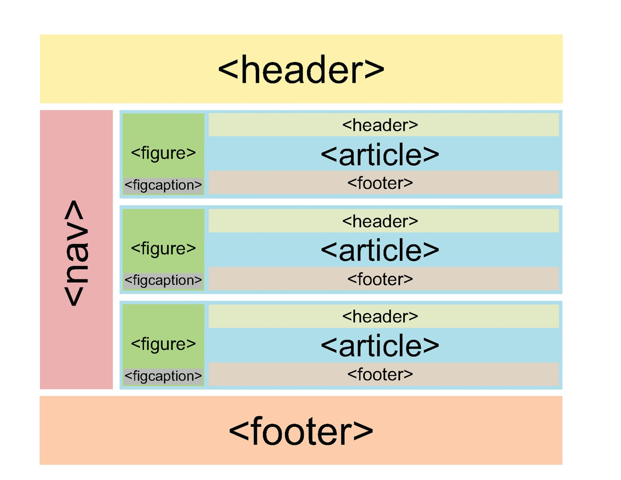

**Fig.3.** Structure of an HTML5 Web Page

**Two Techniques to Make Content Responsive.** Two most common practical techniques to make the content more responsive are discussed below in brief.

1. **Lazy Loading.** It is a technique which is used to not load those images and videos that are not visible in the browser’s visual viewport at a particular time [14]. As the user scrolls down to the media content, it is then loaded as required. It is an intelligent way to lazily load the heavy media content which might never be viewed by the user of mobile devices and hence increases page load time performance. So our intent here is to increase user experience by providing faster page loads dynamically.
2. **Selective Content Loading (SCL).** A best example of SCL implementation is Facebook’s infinite feed scrolling. As the user keeps scrolling down the feeds page, older feeds are loaded dynamically up to the point the user scrolls. The moment user stops scrolling, more older feeds will never be loaded hence not loading the content which will not be viewed by the user at all. This technique is really useful in conditions when we want to load chunks of content into an already opened web page in a structured way.

## 3 Popular Responsive Web Design Frameworks

From above discussion it is pretty obvious that starting point to create a responsive website is determining proper number of columns to create a fluid grid. Then we need to calculate proportions of the elements and each and every content chunk in percentages, defining correct breakpoints, write more complex media queries, design more complex fluid grids, and so on. It is therefore not an easy task for most of the web developers new to RWD. There are pre-designed responsive frameworks to help make the development of responsive websites easy. These frameworks, if used properly, are greatly beneficial and helpful because:

i) they save a lot of time, ii) have an active community of developers to provide support, iii) websites built using these frameworks are cross-browser compatible, iv) and most importantly a good framework provides extensive documentation to help developers learn how to use that particular framework.

In the domain of web, a framework is a set of structured files, folders, and standardized code of HTML, CSS, JavaScript, jQuery, etc. aimed at providing a basic starting point for development of industry standard websites [15]. There are almost more than twenty Responsive Web Frameworks that exist today and all are free to use i.e. open-source, but in this section we will discuss three most popular and widely used RWD frameworks: i)Bootstrap, ii)Skeleton, and iii)Foundation. These frameworks are built on complex fluid grid systems and are extensively used by a large number of website developers.

### 3.1 Bootstrap

Bootstrap was developed by Mark Otto and Jacob Thorton primarily to be used internally by Twitter in 2011 and later launched as a free software for public use [16]. In it’s initial release, responsive feature was not present in Bootstrap which was added in version 2.

Bootstrap is the most popular responsive framework for developing mobilefirst websites based on 12-column fluid grid system. It is packed with extensive ready-made User Interface (UI) components including glyphicons, buttons, alerts, progress bars, drop-down menus, and much more [17]. The power of Bootstrap comes to action quickly because a developer will only need to download the framework package and start designing responsive websites. Bootstrap also provides video scaling component. Bootstrap code can be customized using LESS or SASS. Websites developed using Bootstrap are capable of running on device resolutions starting with width less than 480px up to 1200px.

In a nutshell, Bootstrap is easy to get started, offers a great grid system, provides styling rules for fundamental HTML elements such as headings, lists, tables, buttons, forms, etc., provides extensive UI components, packed with built-in JavaScript plugins to make UI components more interactive, and most importantly supported by extensive documentation.

Following are examples of websites built using Bootstrap:

* Codecademy, Teaching the world how to code, http://www.codecademy.com
* Opendesk, design for open making, https://www.opendesk.cc
* CodrSpace, the blogging platform for coders, http://codrspace.com

### 3.2 Skeleton

Skeleton is a lightweight CSS responsive framework created by Dave Gamache. Skeleton is the simplest framework as compared to other two discussed in this monograph. It is not overstuffed with heavy styles, extensive UI components, and JavaScript/ jQuery plugins. Skeleton is good for smaller projects in which large number of utilities are not required. Skeleton uses 12-columns fluid grid system with a maximum width of 960px. Skeleton comes with a starter HTML template (index.html), and two lightweight CSS files (normalize.cc and skeleton.css) and that’s the reason it is called a lightweight framework because intent of skeleton developer is to provide responsive only components without rich styles and plugins.

Following are examples of websites built using Skeleton:

* GetSkeleton, official website of Skeleton, http://getskeleton.com
* HiveMind, a design agency, http://www.ourhivemind.com

### 3.3 Foundation

Foundation was built by a team at ZURB, a California based product design agency. Foundation is also an open source project and mobile-first framework. Unlike Bootstrap, Foundation do not have much pre-defined styled UI components however it has rich designed elements and built-in JavaScript plugins. A developer needs more technical skills to work with Foundation in that it is based on Ruby language and one need to install Ruby in order to start working with Foundation. SASS, SCSS and Ruby together make Foundation as the most advanced responsive frameworks as compared to Bootstrap and Skeleton. Following are examples of websites built using Foundation:

* HTC, official HTC Shop, UK, http://goo.gl/d9zAGH
* Canadian Olympic Team Official Website, http://olympic.ca
* iStockPhoto, Perfect Digital Stock Photos, http://www.istockphoto.com

## 4 Tests to Check Responsiveness of a Website

In this section we will see some methods that exist to check if a website is responsive.

### 4.1 Google Mobile-Friendly Test

Due to the growing popularity of Responsive Web Design, Google announced mobile-friendly testing tool in the end of year 2014 [18]. This has completely changed the ranking of websites in Google’s search results. No matter how structured and search engine optimized a website is but if it is not mobile-friendly, it will certainly be displayed below mobile-friendly websites in search results. As per official Google Webmaster blog, a website will only be eligible for “mobilefriendly” tag if it fulfills the following criteria as identified by Googlebot [18]:

1. A web page should avoid software which is not supported by mobile devices

e.g. Flash, JAVA plugin, etc.

1. It should not use the text which would require zooming to read.iii. A page should not require horizontal scroll or pinching/ zooming.

iv. There should be enough space between navigational links so that the targeted link could be easily tapped.

The link of Google’s mobile-friendly test tool to check an individual web page is https://www.google.com/webmasters/tools/mobile-friendly/

A site’s ranking in Google, the most famous search engine, when used on mobile devices now also depends on mobile-friendly test. That’s a big reason why companies are getting their websites responsive.

### 4.2 Browser Window Resizing Trick

By resizing the browser window it could be checked that whether a particular website is responsive or not but this type of test is not reliable. For example, if a website uses media queries and device-width instead of width property to determine breakpoints then window resizing test will not work due to the reason that device-width, i.e. desktop/ laptop layout viewport, will remain constant and only visual viewport is changing. However, this test will work for most of the websites.

### 4.3 Mozilla Firefox and Google Chrome Built-in Responsive Tests

Mozilla Firefox comes with a built-in *Responsive Design View* mode to help developers test their websites during development process and see if there are any issues associated with the responsiveness. To enable Firefox’s built-in responsive test simply press Ctrl + Shift + M on windows or Cmd + Opt+ M on Mac. Same key combination will disable the responsive design mode. It may be required to refresh the website when current size is shifted. Figure-4 below shows the *Responsive Design View* test on http://www.creativebloq.com/.

Similarly, Google Chrome also offers more advanced responsive design test, than of Firefox, namely *Device Mode & Mobile Emulation* (DMME). Chrome’s device mode is used to test the responsive design by simulating different screen sizes, resolutions, media queries, and retina display. Chrome’s DMME also supports network emulator to test the site performance when loaded using different network bandwidths. Thus, by changing device size, network type, and providing device-pixel-ratio value one can test the responsiveness of the website in closer to reality. Google Chrome provides a rich list of mobile devices to emulate, and this

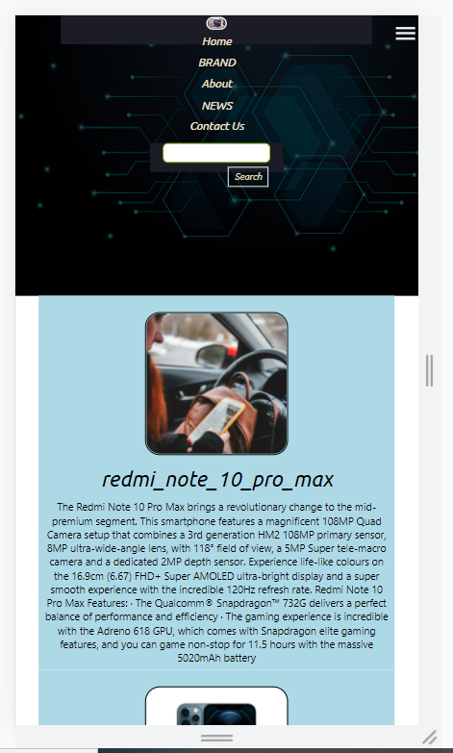

**Fig.4.** Google Chrome’s Responsive Design View Mode

list is continuously updated by Google as and when new devices are launched. To enable Chrome’s DMME simply press Ctrl + Shift + I on windows or Cmd + Shift +I on Mac. Figure-5 below shows the same creativebloq.com website in Chrome’s DMME. The blue, green and orange horizontal bars represent media query breakpoints which can be invoked by clicking in between the tiny vertical bars in white color on breakpoints bars and the website’s layout will respond accordingly.

### 4.4 Remote Testing Resources

All the above tools and techniques for testing responsive design are closer to reality and never provide 100% accurate result. So the actual solution would be to test on as many devices as possible which give accurate results. This doesn’t mean one have to buy as many physical devices to test on. Remote testing resources are a great way to implement mobile testing by interacting with multiple physical devices as we do in reality. These remote testing resources are available on the internet, freely or paid, in the form of web based interfaces. Some remote testing resources are:

* Samsung Remote Test Lab, http://developer.samsung.com/remotetestlab/
* AppThwack Labs, https://appthwack.com/
* Vanamco’s GhostLab, http://vanamco.com/ghostlab/

## 5 Responsive Web Design in Future

To predict the future it is important to study the past and present so that’s the reason why the above discussion is detailed. We can now say that in 2015 it’s not almost possible to deny a responsive web site. Web designers and developers whenever say ‘web design’ they simply mean responsive web design. But being device agnostic i.e. adapting to different screen sizes is only the first milestone of a responsive web of next generation. Users expect a web experience that would also respond to certain parameters like their location, time of day, what they have already accessed (web surfing history), and events happening in real time around them [19]. Therefore the future of responsive web design lies in responsive thinking web. If we pickup a series of print publications of a printed magazine we may realize that each edition has different layout and design i.e. it has the ability to respond to any combination of events happening around. This ability is somewhat missing in today’s responsive web. Most of the websites have same (4 to 12 column) layout all the time, in all the major happenings, and day in and day out. No matter how big the news is, either war begins in Yaman or it’s Pre-poll rigging issue, we have the same layout and style of our article pages. Therefore, website should not only respond to device sizes instead the website, and content itself, should adapt and reshape to certain contexts. For instance, Web Directions South 2012 have used physical location of their participants to shape the homepage of their website[3]. Their homepage changed to the schedule of the event once a participant has arrived at the venue.

Older adults, i.e. senior citizens, are the fastest growing number of web users [20]. Web designers have to tailor websites keeping in mind the needs of this large growing population. These senior web users have some usability issues associated with them e.g. the way information is organized and presented in design-rich websites, text color, style and size, finding information on the go, etc. due to the age in which they have started to surf the web. It’s not as easy for an older adult to become handy on the web in lesser time as compared to the users falling in the age range of 45 to 55 and it’s a natural phenomena that more younger people are capable to learn and adapt to new things easily. So we have got another context which would require web developers to write complex and intelligent algorithms smart enough to sense stored user profiles and layout and style the content which is convenient for reading, browsing, navigating and understanding by senior adults. Most popular social services like Twitter, Facebook, and Gmail have algorithms which work to check if a new user have registered. A new user after logging in will be presented with some tips & training on how to get on using their services quickly. That’s a context aware serving of services in which they have a *new user context* but what if that particular new user is a senior citizen which might get stuck with their somewhat advanced basic tutorial. So beside detecting the user type only web developers will also need to target the aging factor. We can say that if a user is new to this website then serve this content first AND if the user is a new one AND falls in this age category then present this content first in that layout AND using these style rules, etc.

Another potential context is cross cultural website. Each culture has inherent differences, values, ethics, and well-defined way of lifestyle. Online trade, communication technologies, social networking and news websites have all, more or less, contributed towards cultural mixes and thus creating a global culture. Responsive web design has made all these informational websites more accessible and user friendly. This has posed serious issues for developing countries like Pakistan to protect their cultural values. Developing countries, like ours, are trying to resist against this cultural change but the world is moving ahead to more globalization and technology itself has formed its own global culture. Global culture is, at large, being shaped by developed countries who are sitting at the driving seats of invention, production, and distribution of information and communication technologies. The websites like news, articles, blogs, networking platforms and online shopping were far away from the approach of non-computer users before the advent of responsive web design. The users of these websites significantly increased after these websites have been turned to responsive. Global community nowadays is not using mobile devices to stay in touch but they are doing a lot more. People have made much awareness through social media websites that they had even organized such a revolution by using these platforms that caused some Governments, like Pakistan, to put a ban on these websites in their countries. So this is much evident that responsive web design, by providing accessibility and availability of websites, has posed serious impacts on the way people are living.

Culture, hence, becomes another context in responsive web design where, for instance, an online shopping website based in a western country when accessed in Pakistan would not show the content which is not permitted by our religious cultural ethics and values. But there should be some way to override this behavior if minorities living in Pakistan want to get access to the full version of the website content. This is only the single example of how we could use cultural context in responsive web design and if properly implemented this will help web users of religious families to access the web content on such websites that they feel uncomfortable to surf publicly because only the text and figures, without half-dressed male/ female models advertising on such online shopping websites, will make no harm to their cultural values. Hiding religiously banned material whenever viewed in such a zone is just one parameter discussed here and there could be a lot more. Therefore, responsive web designers and developers need to take into account such considerations to make a cross-cultural responsive website. On more positive side, web designers could even offer content which highlights and expresses culture and cultural values of their users in whatever part of the world they are surfing web. This will add a positive impact to the goodwill of companies in their users eyes.

## 6. Proposed Methodology :

A methodology was developed based upon a combination of the available literature and the experiences of one of the authors, who is actively involved with the development of Web-sites. Whilst this has obvious benefits with regards to experience within the subject area, it can also prove problematic. Walsham explains how such an “Involved-Researcher” can bring the benefits of their experience to assist the research process. However, as Winter points out, this can also have the disadvantage of utilising preconceived ideas and having particular expectations about the research results. Once the methodology had been developed, it was then presented to two experienced developers for evaluation. This provided additional indications regarding the usefulness of the methodology on a more practical level. The following section presents the stages of the methodology

## 7. Architecture

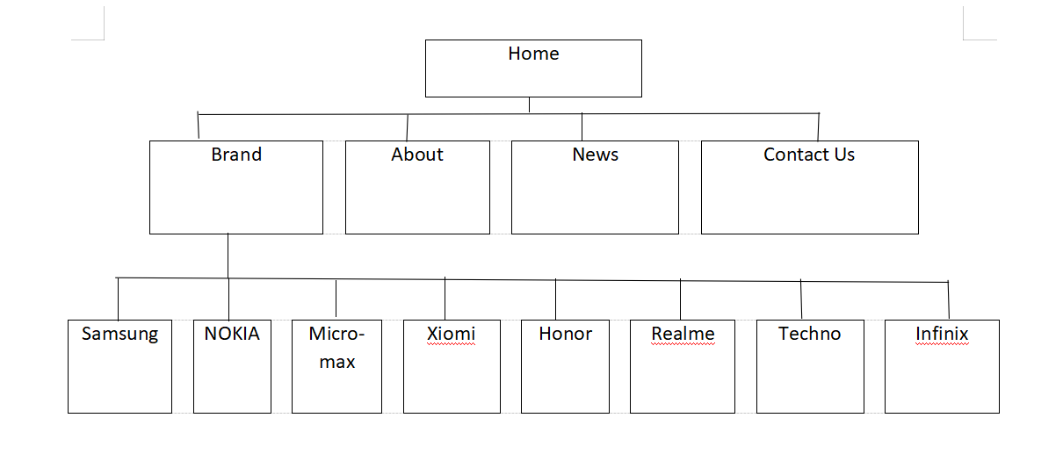

**Figure: Architecture Diagram**

## 8. Implementation:

***Nessary Images:***

At First we have to download few nessary images.

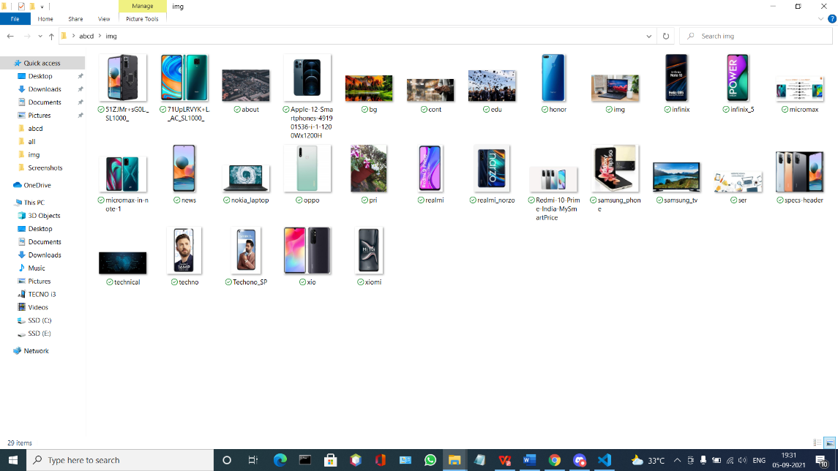

Then, THE Home.html

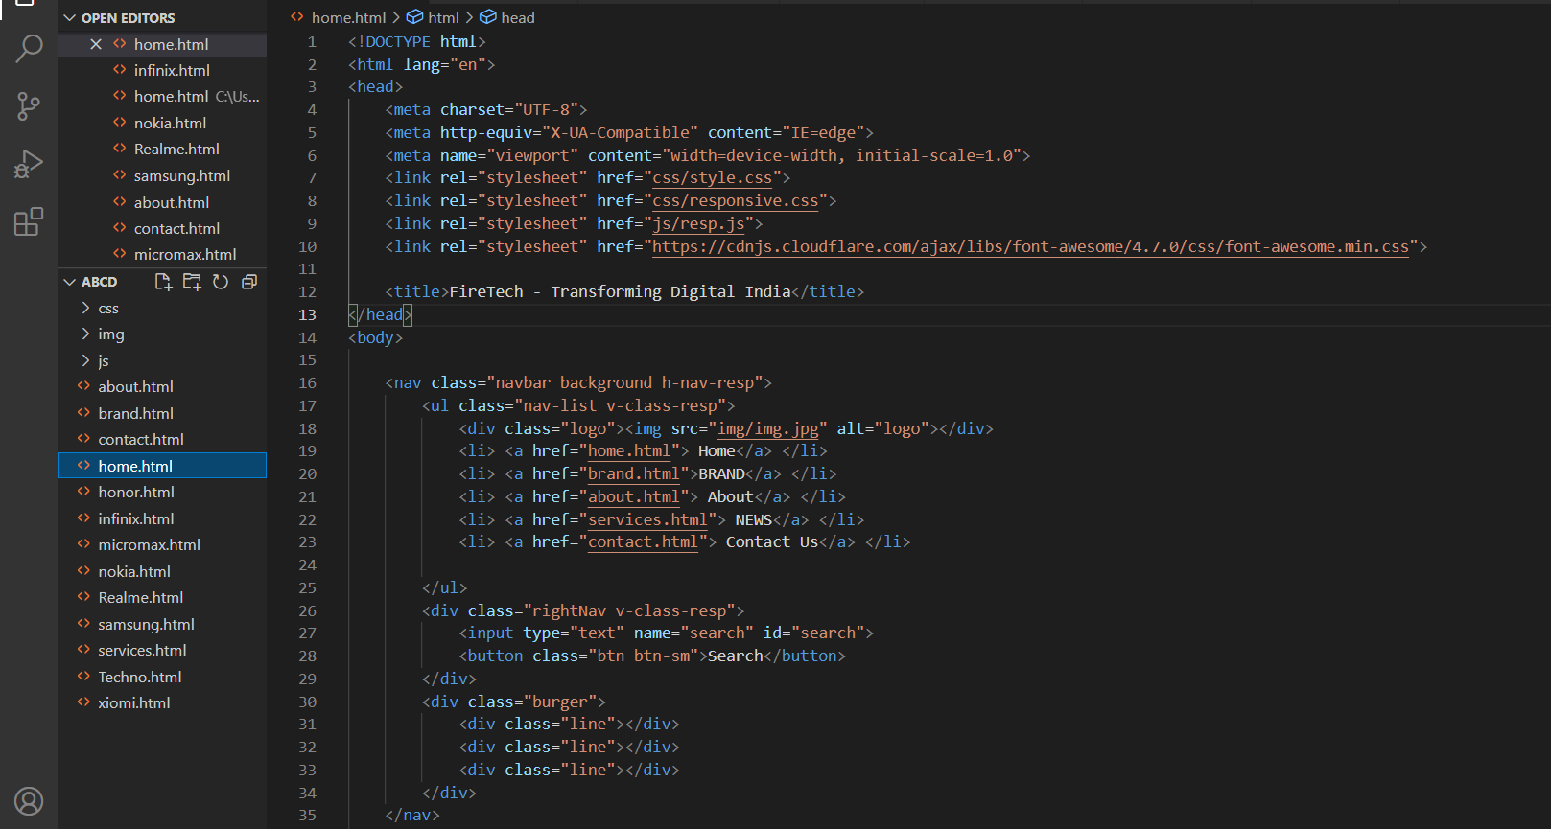

**Explanation:-**

Here We are Develop the HEADER and NAVIGATION PANEL

AND the Style.css file is

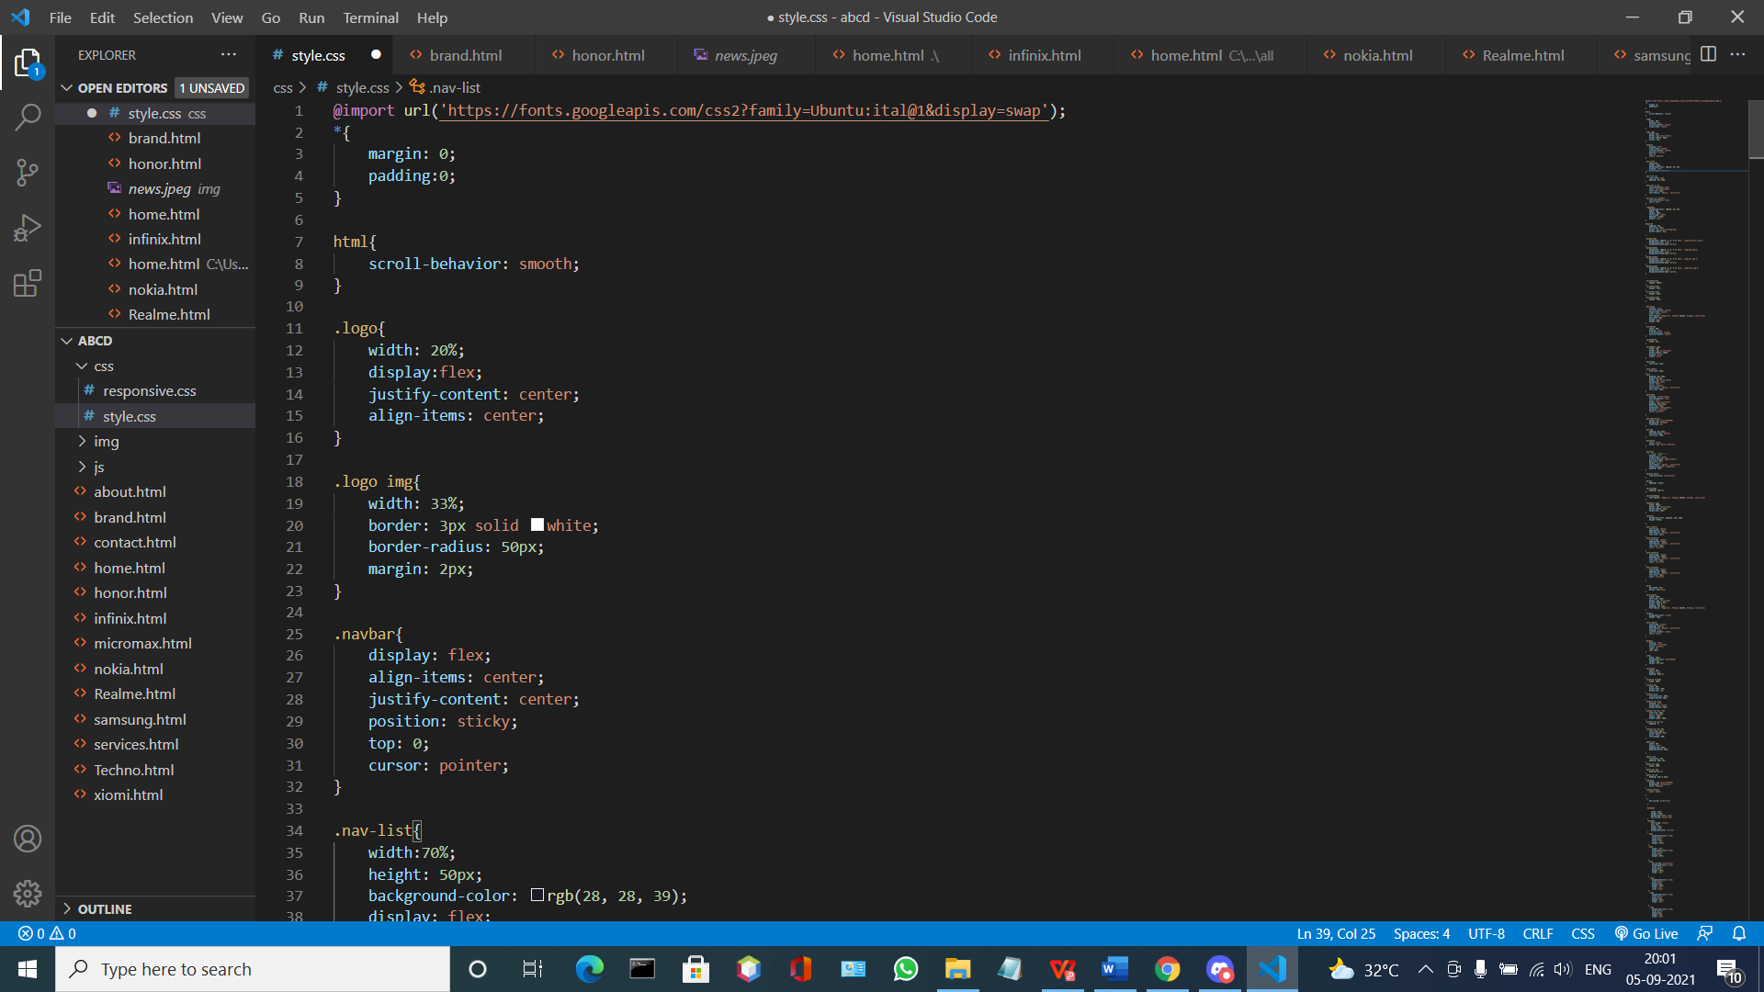

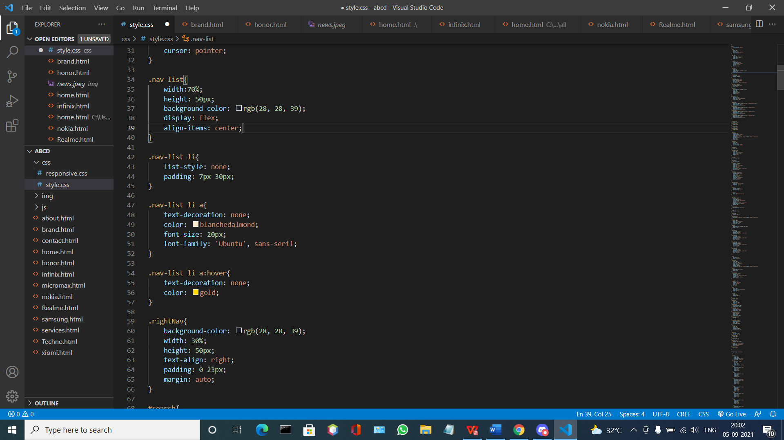

**Explanation:-**

Here We are Design the HEADER and NAVIGATION PANEL using style.css.

In our case the navigation bar is divided into two part one left-nav and right-nav

Left-nav=nav-list, right-nav=rightNav

**OUTPUT:**

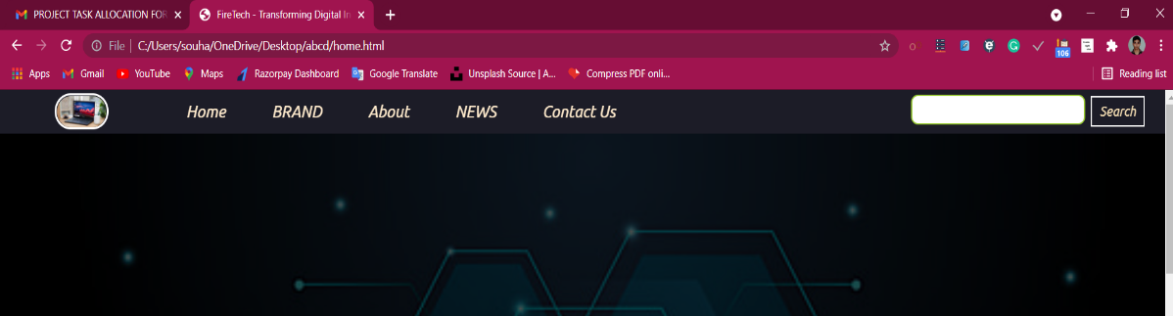

**Automatic Img change:**

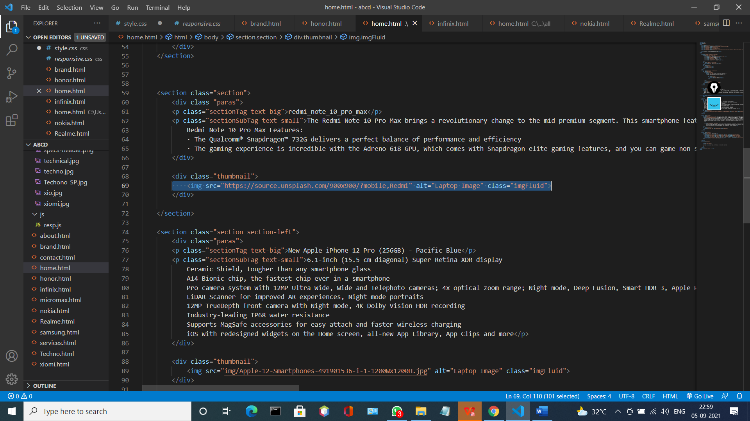

**Explanation:-**

 <link rel="stylesheet" href="https://cdnjs.cloudflare.com/ajax/libs/font-awesome/4.7.0/css/font-awesome.min.css">

This line will change the image automatic

**OUTPUT:**

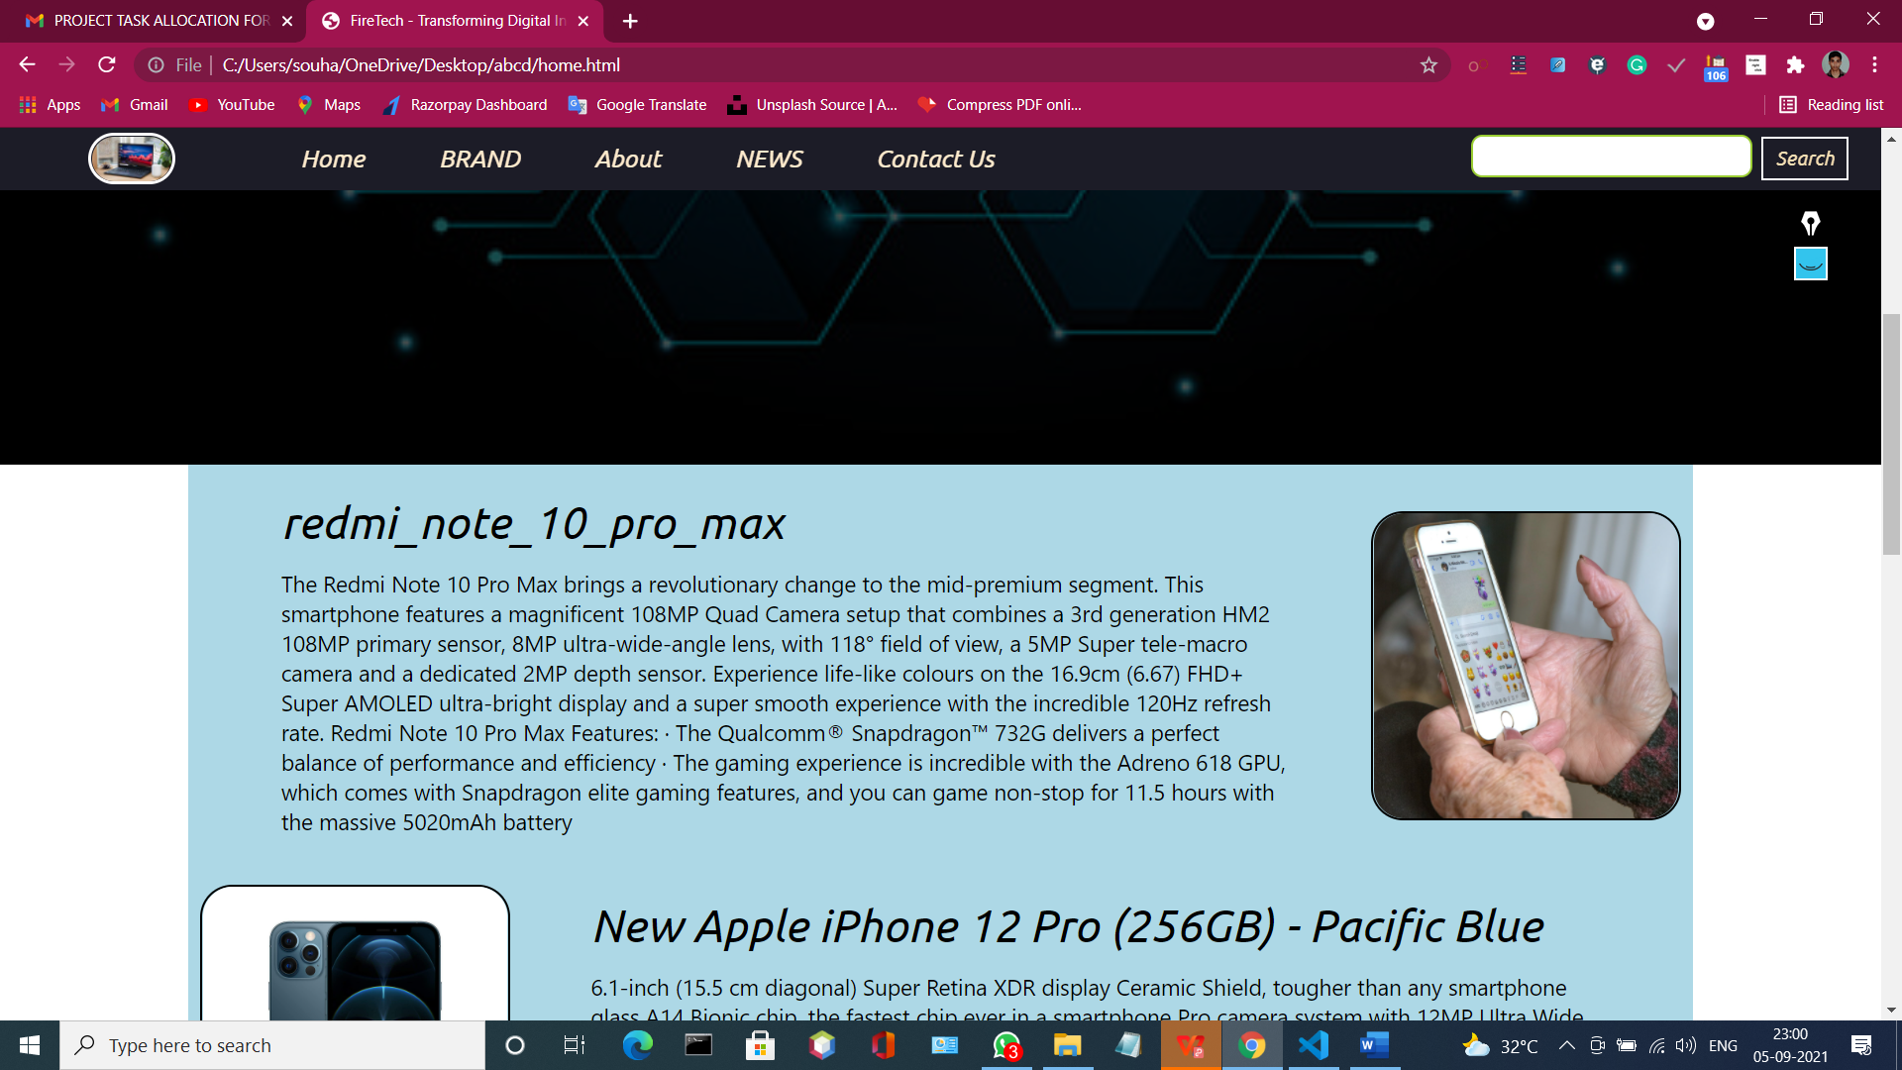

**FOOTER:**

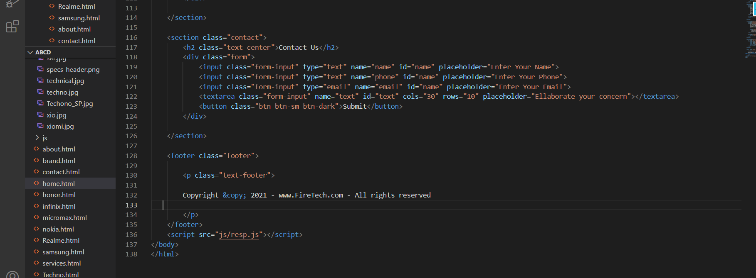

**Explanation:-**

Here we add footer for the design Purpose.

**OUTPUT:**

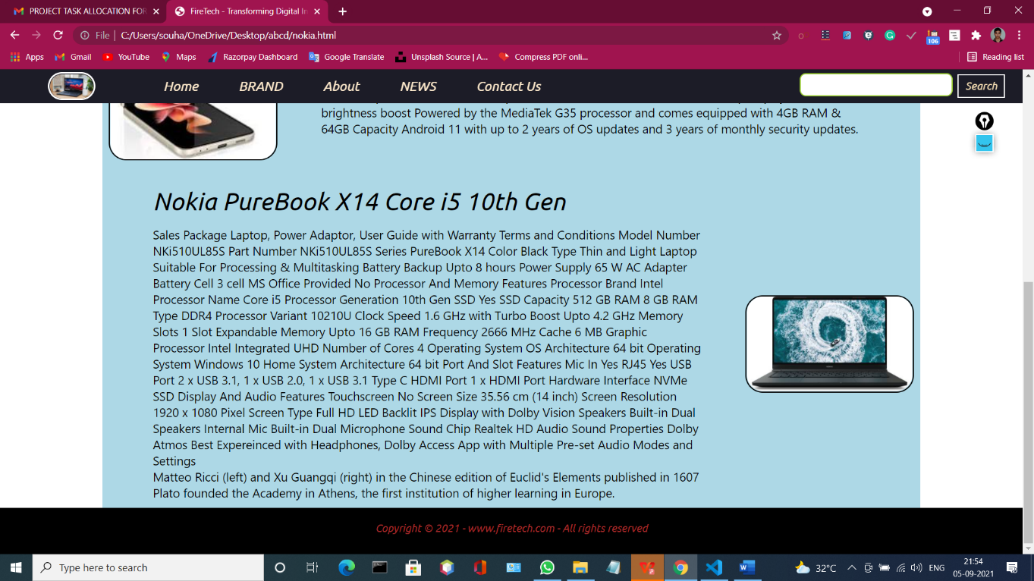

**FOR MAKING OUR WEBSITE RESPONSIVE:**

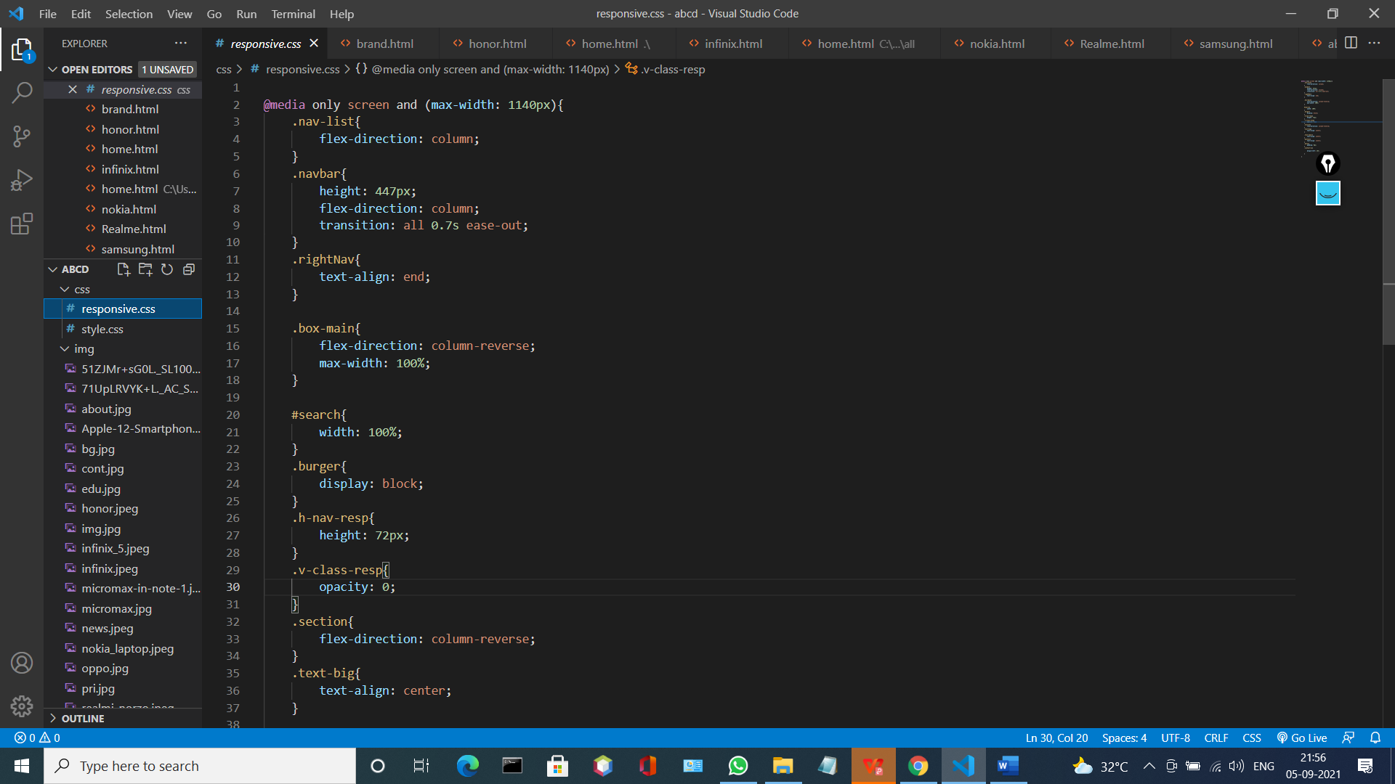

**Explanation:-**

When I view the website in the mobile or Tablet that time

We have to do add some media Query for make this website responsive

Like here we add max-width : 1140px after that range the website will be

Automatically responsive for that purpose we also add the menu boutton like .burger class and .line also for that we have to see the Home.html page

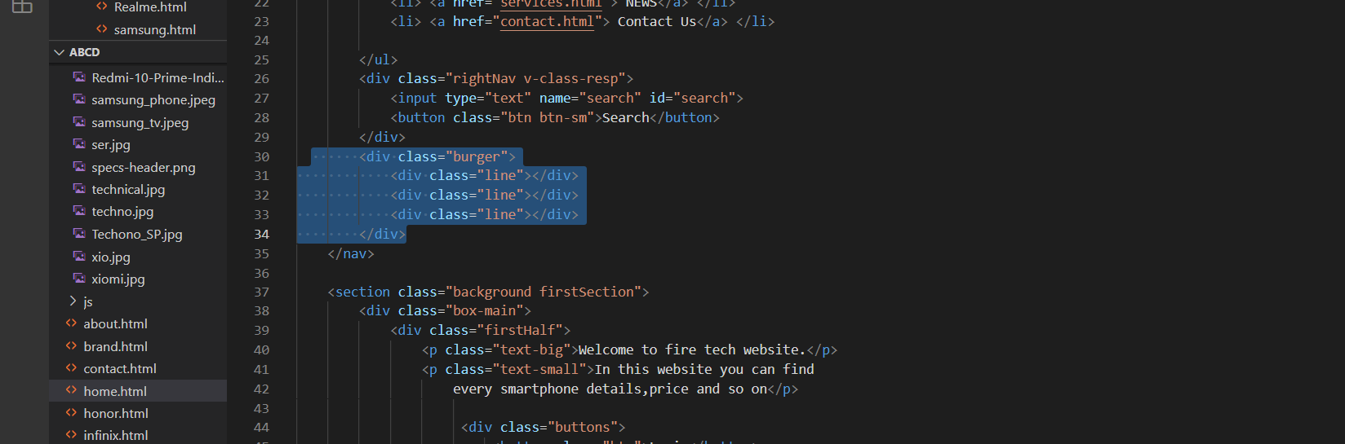

And also we have to add the javascript also.

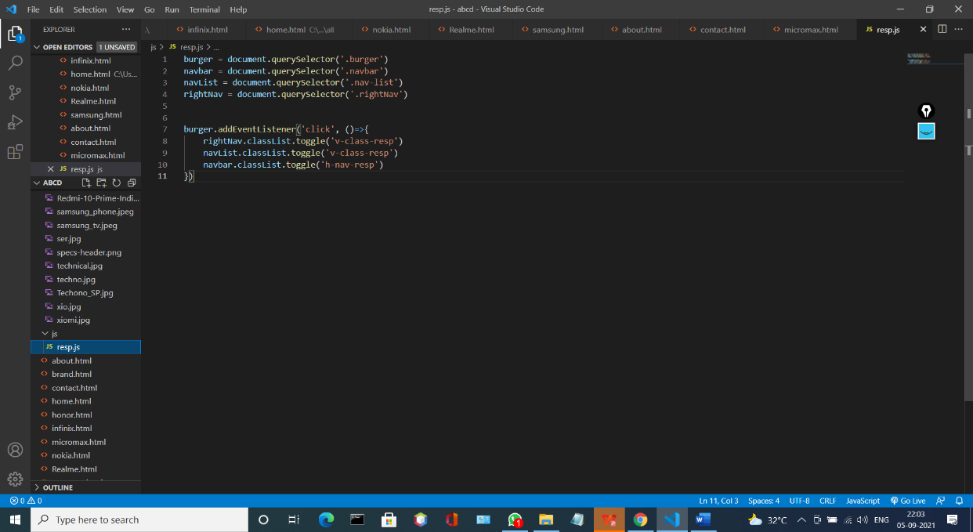

**Explanation:-**

Here we are using toggle function into the Actionlistener.

**OUTPUT:**

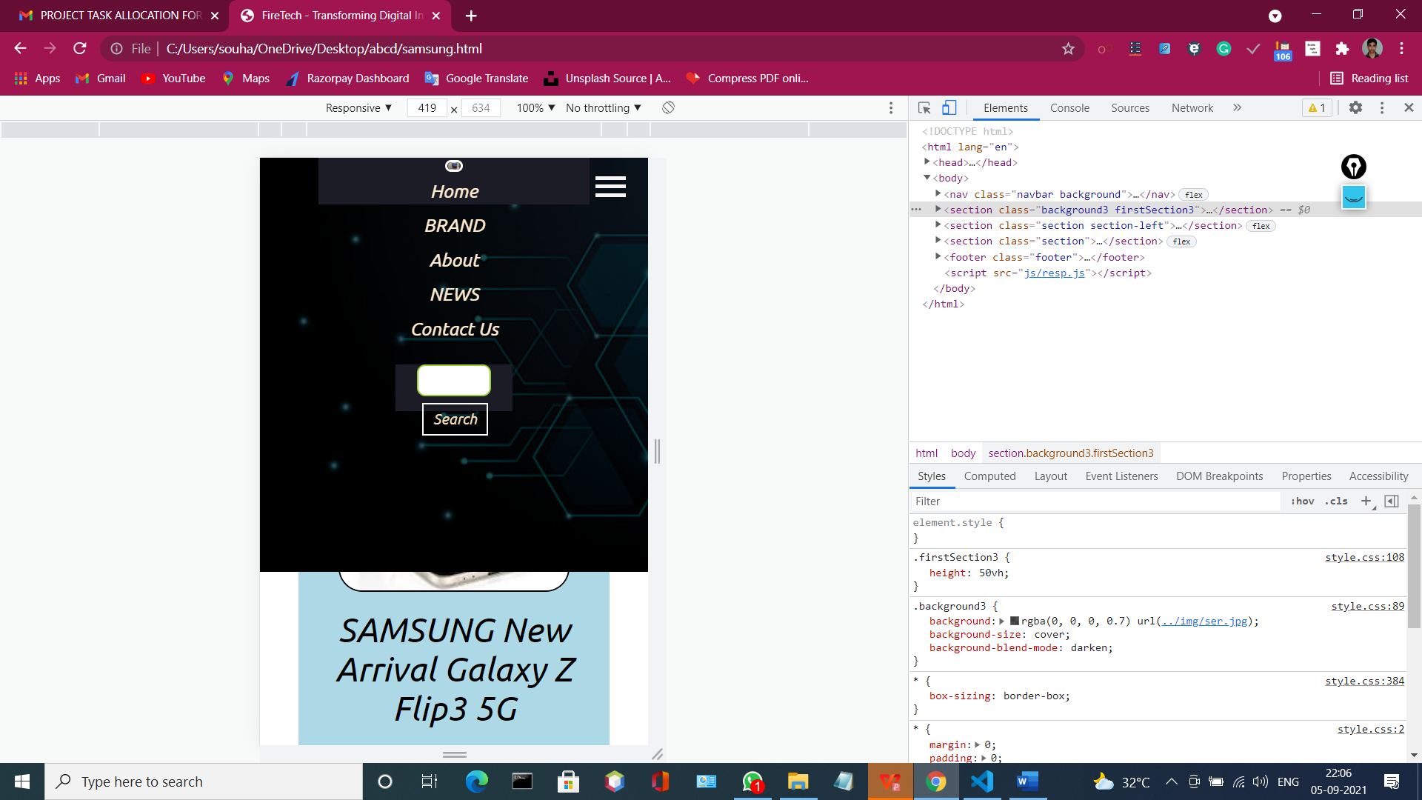

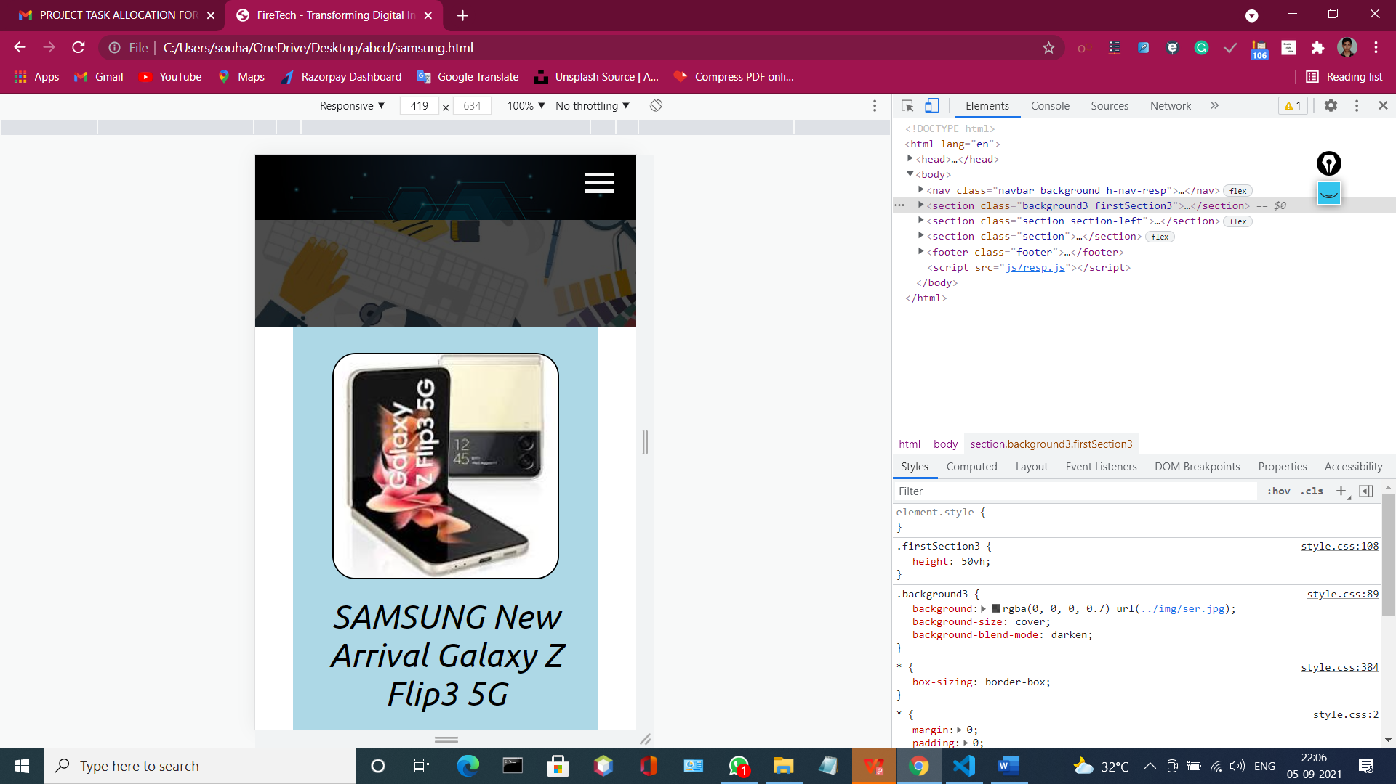

This is Completely Responsive and it work properly in case of any mobile and tablet devices.

**BRAND.html**

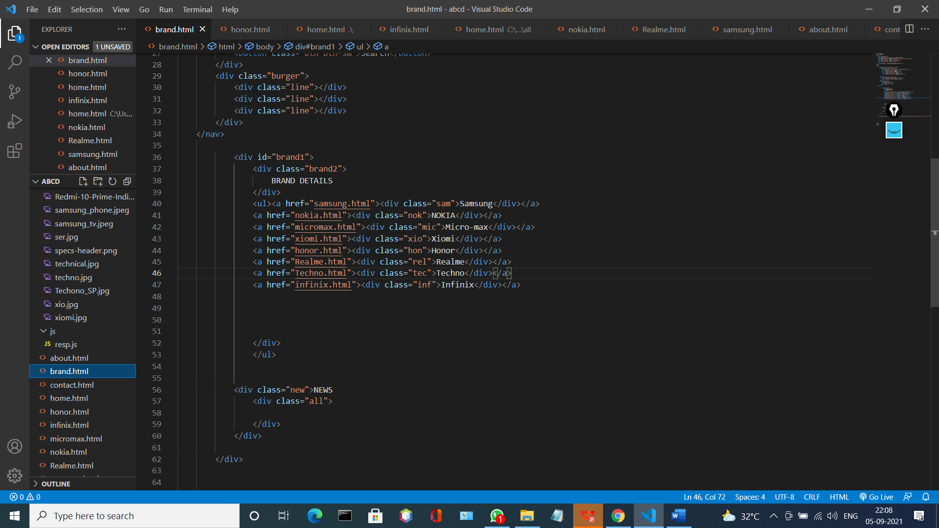

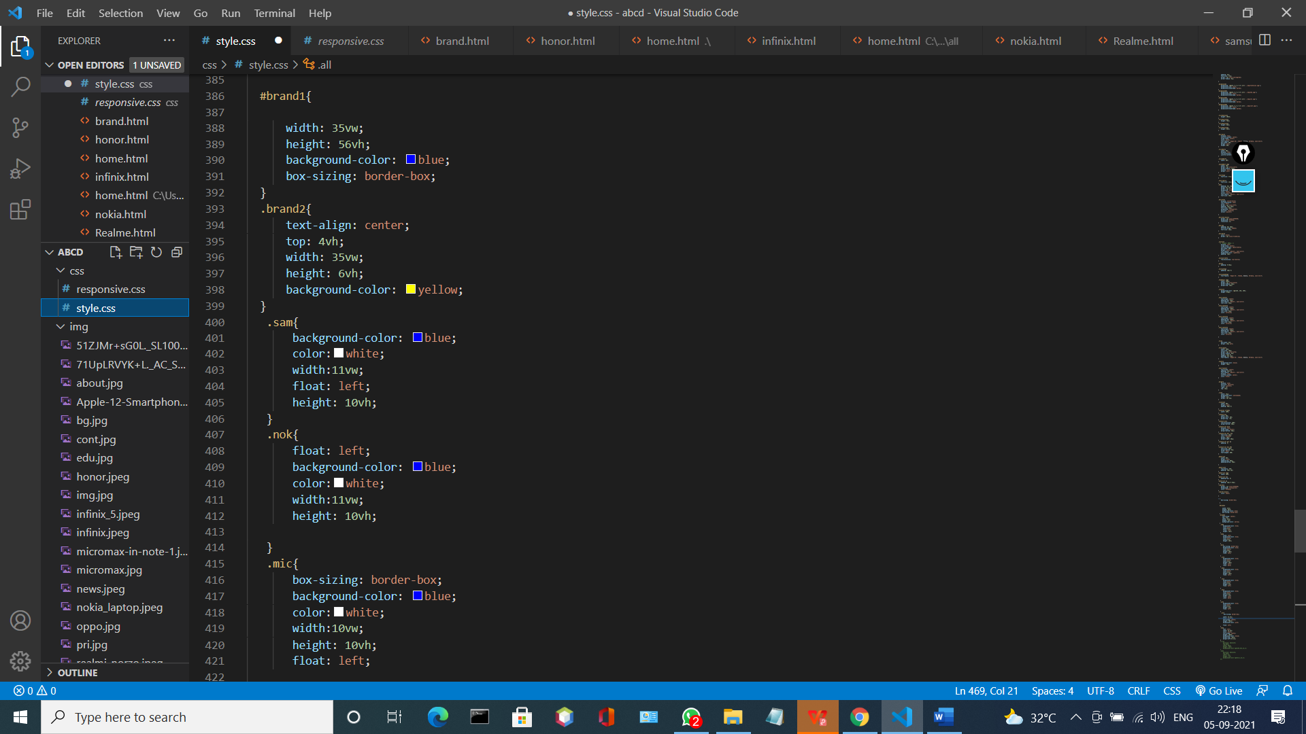

It is the .css part of the brand.html here .all and .new class use for the develop in future.

**Explanation:-**

Here we are adding many kind of brand like Samsung, nokia, Realmi etc.

For that purpose we are creating a class that name is Brand2

And that contains many kinds of brands href link

**OUTPUT:**

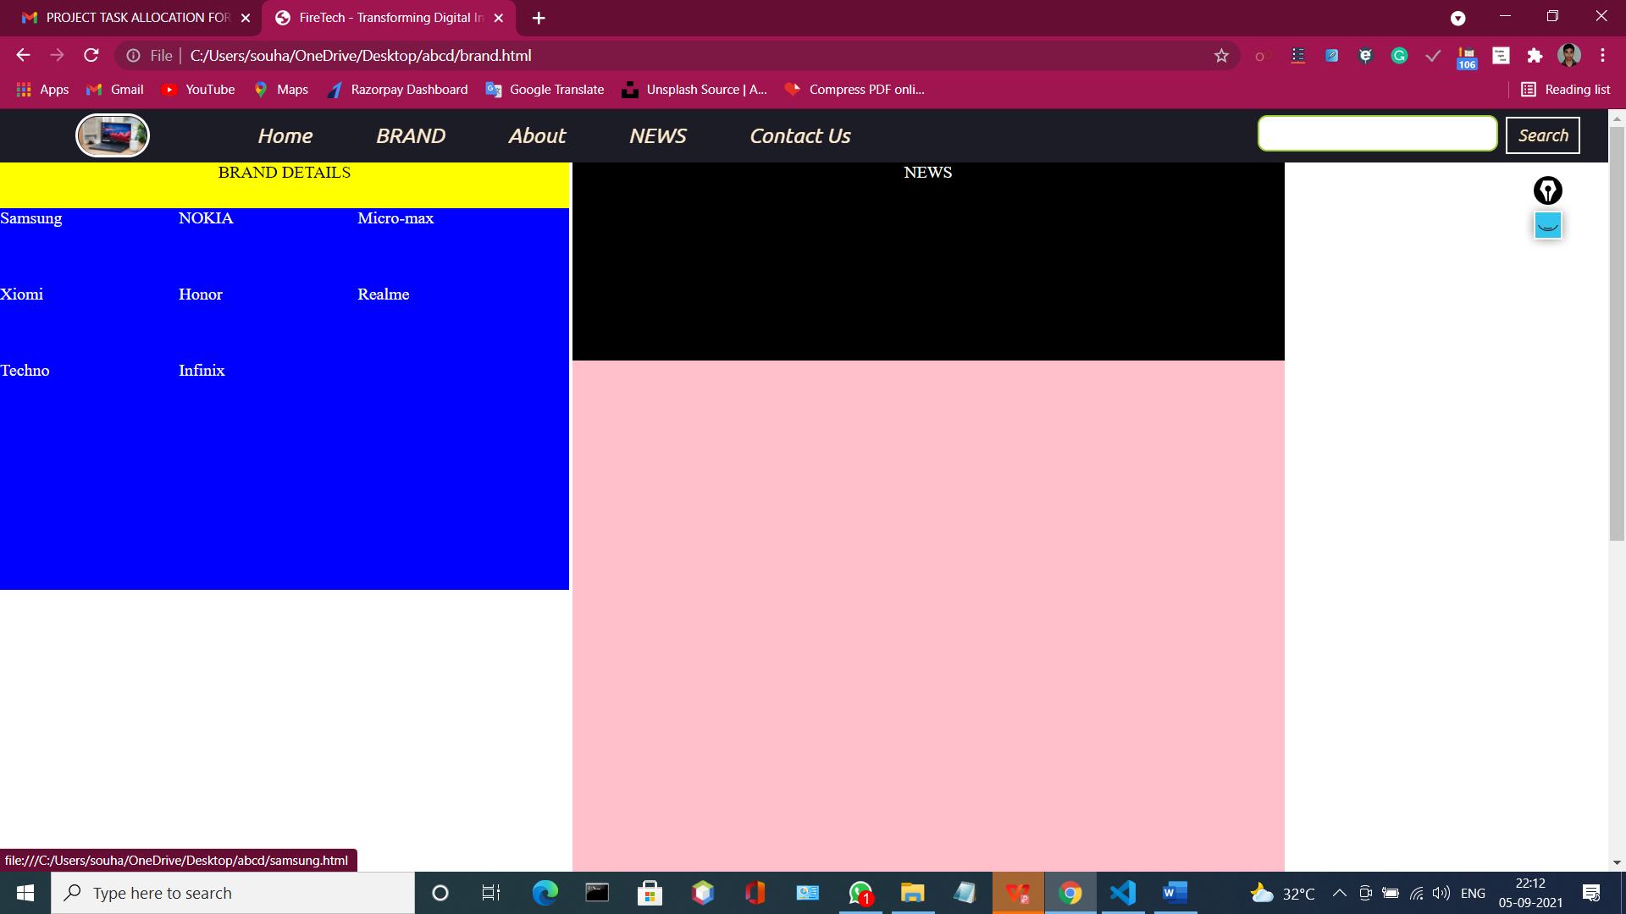

When I click Samsung that will refer to me a new web-page like

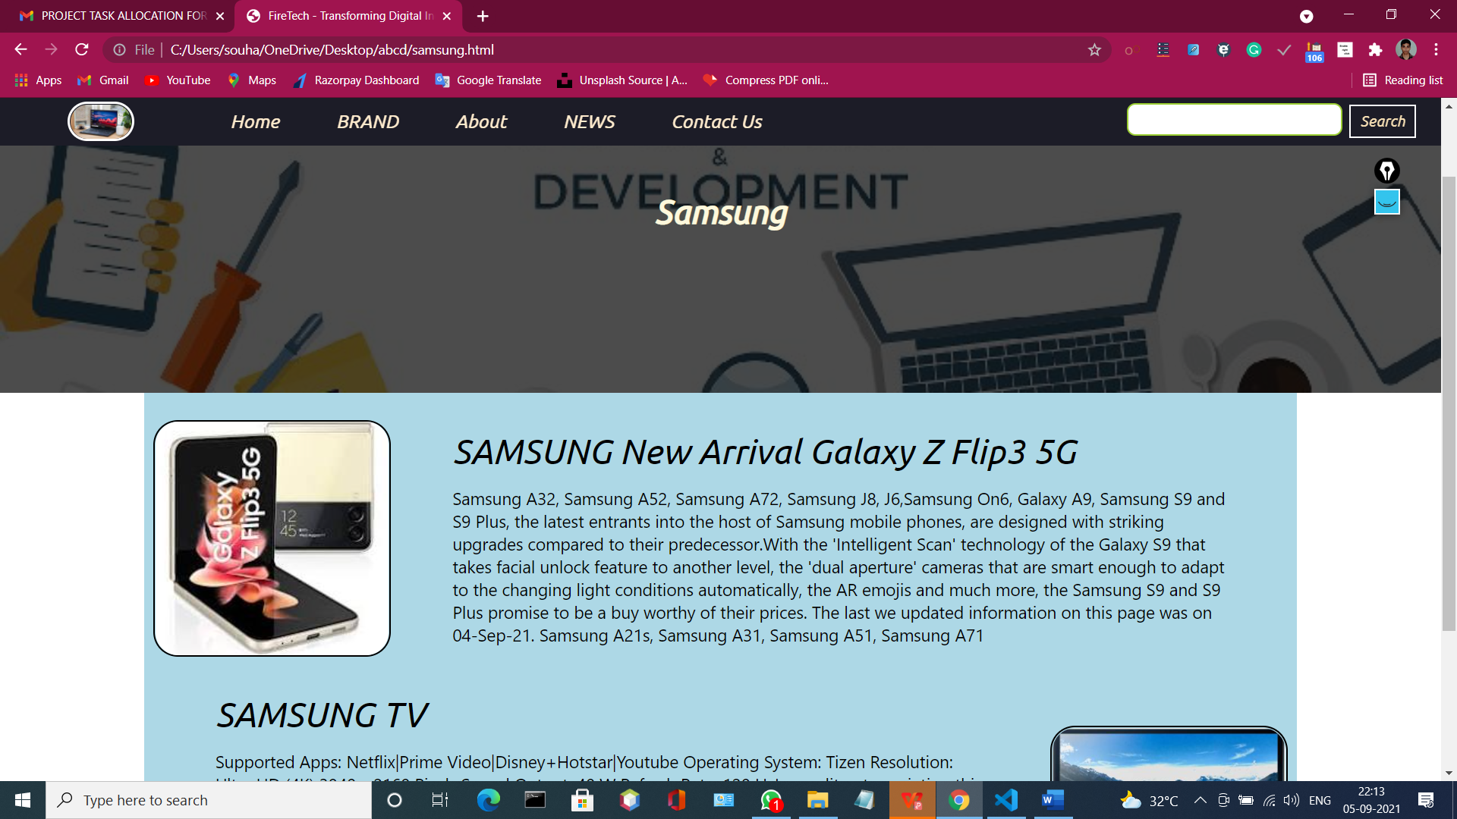

And also

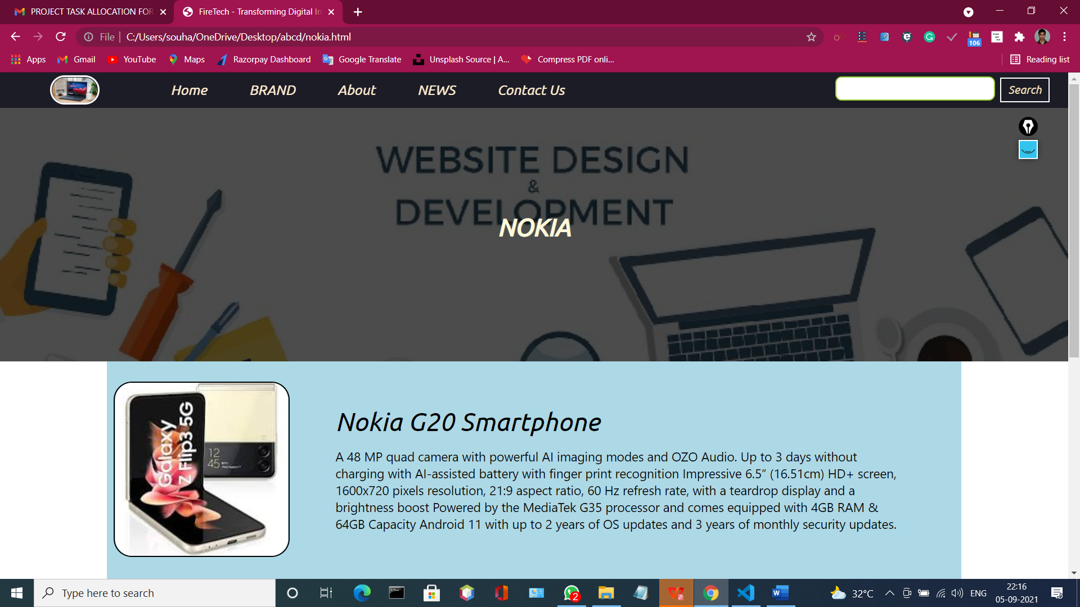

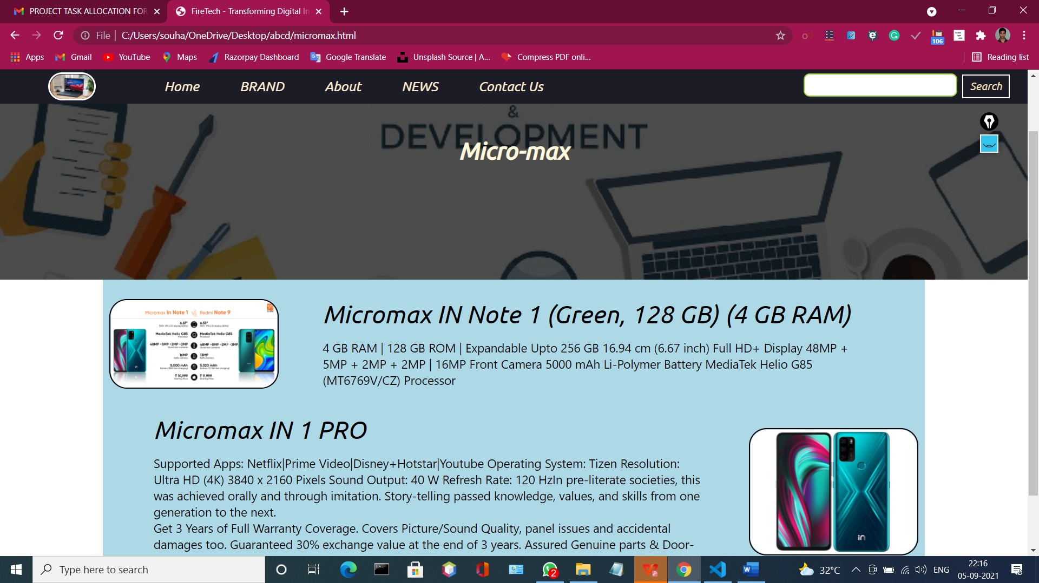

And that’s go on and their html code is

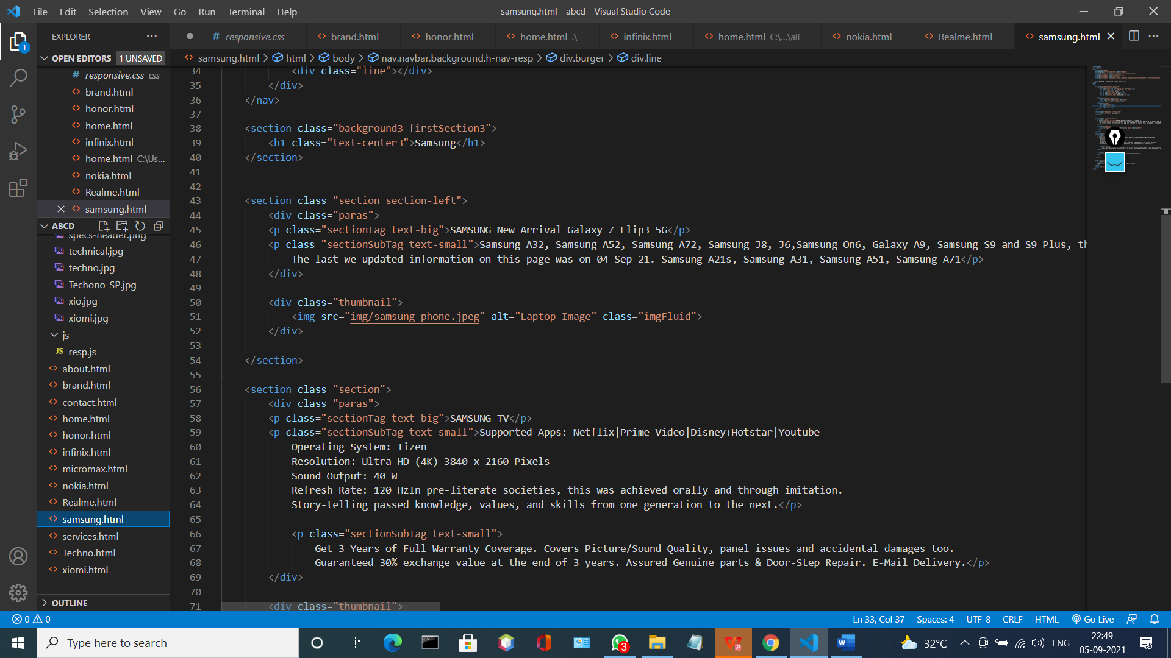

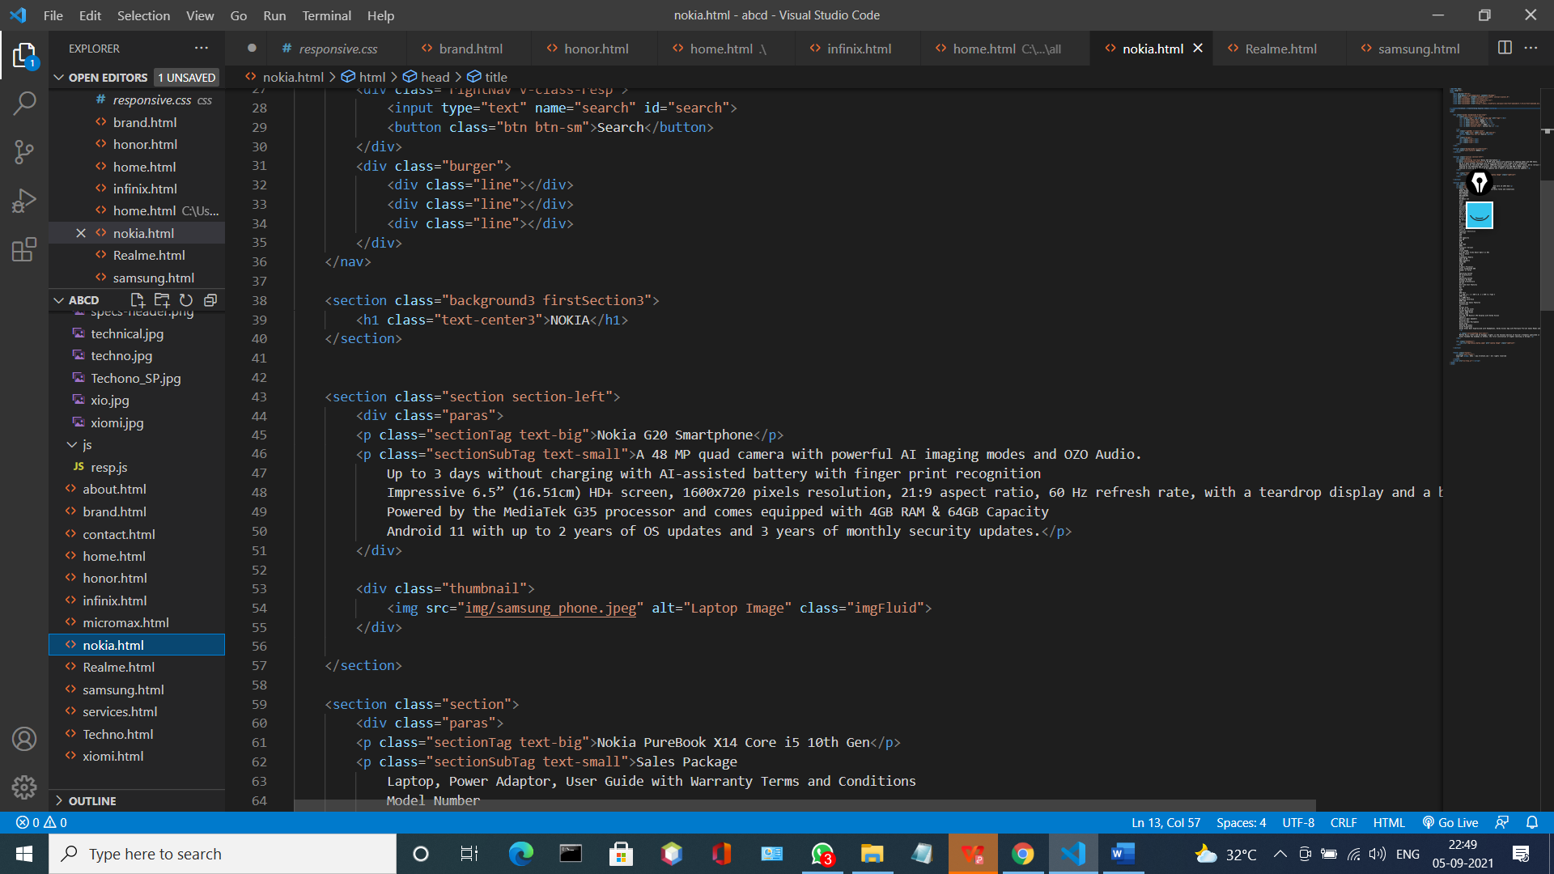

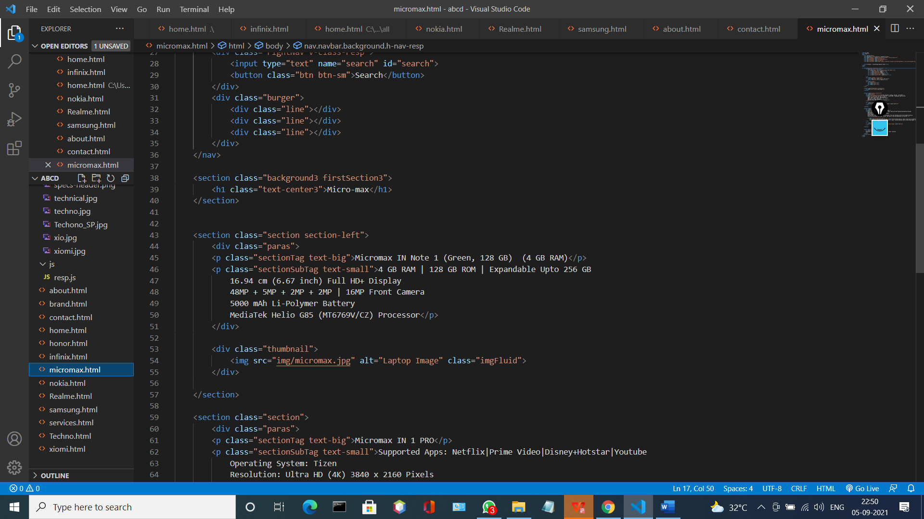

NOW,

**ABOUT.html**

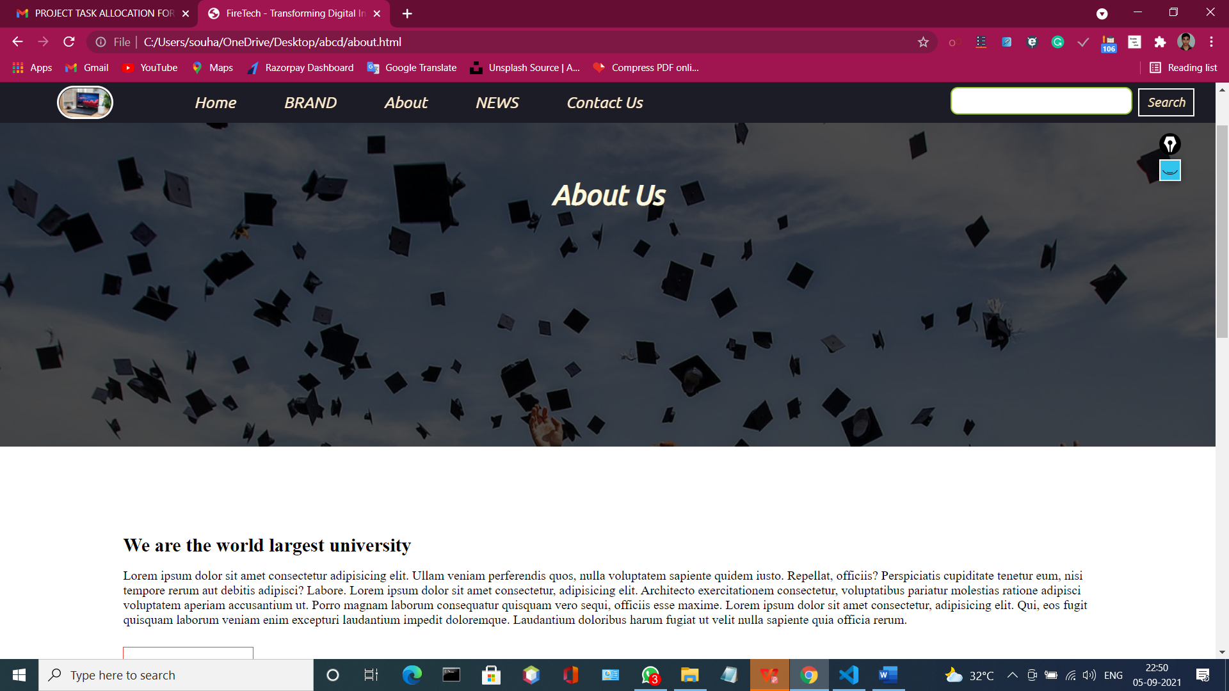

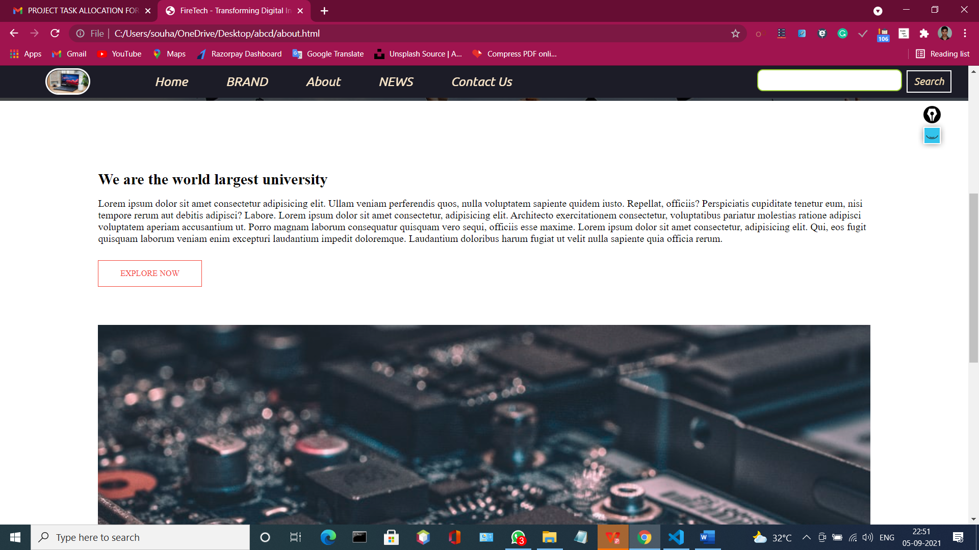

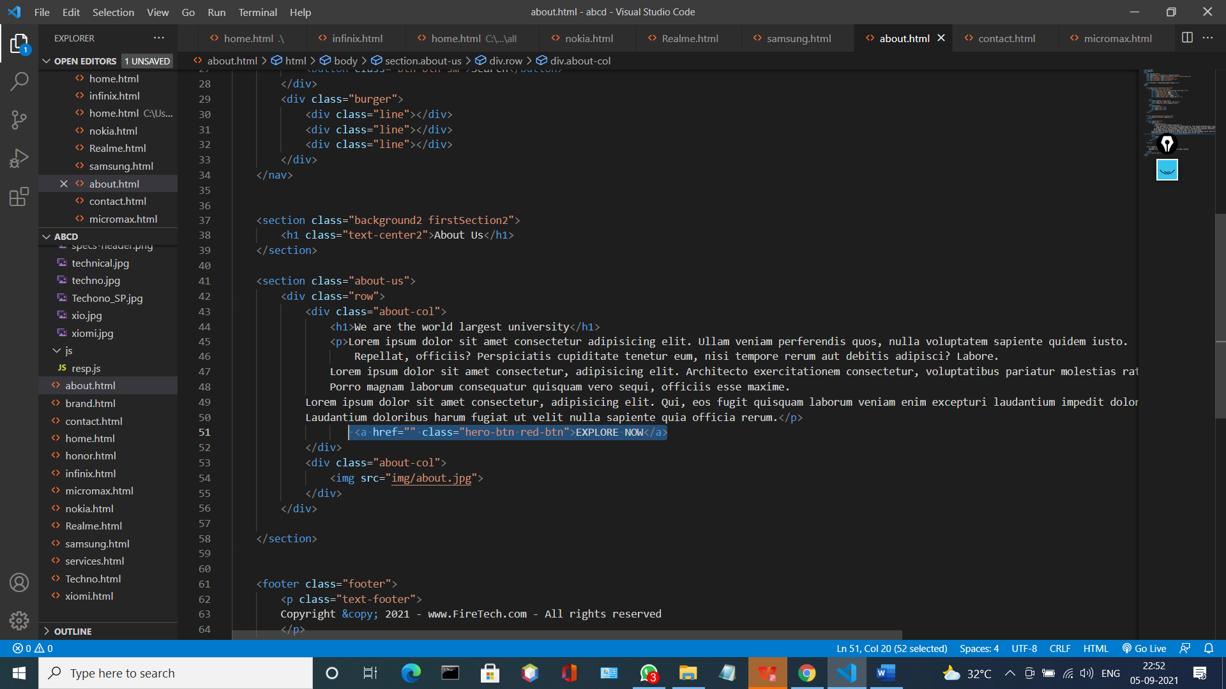

**Explanation:-**

When I take the cursor in EXPLORE NOW button that time it will be red

Because we add here some .css code.

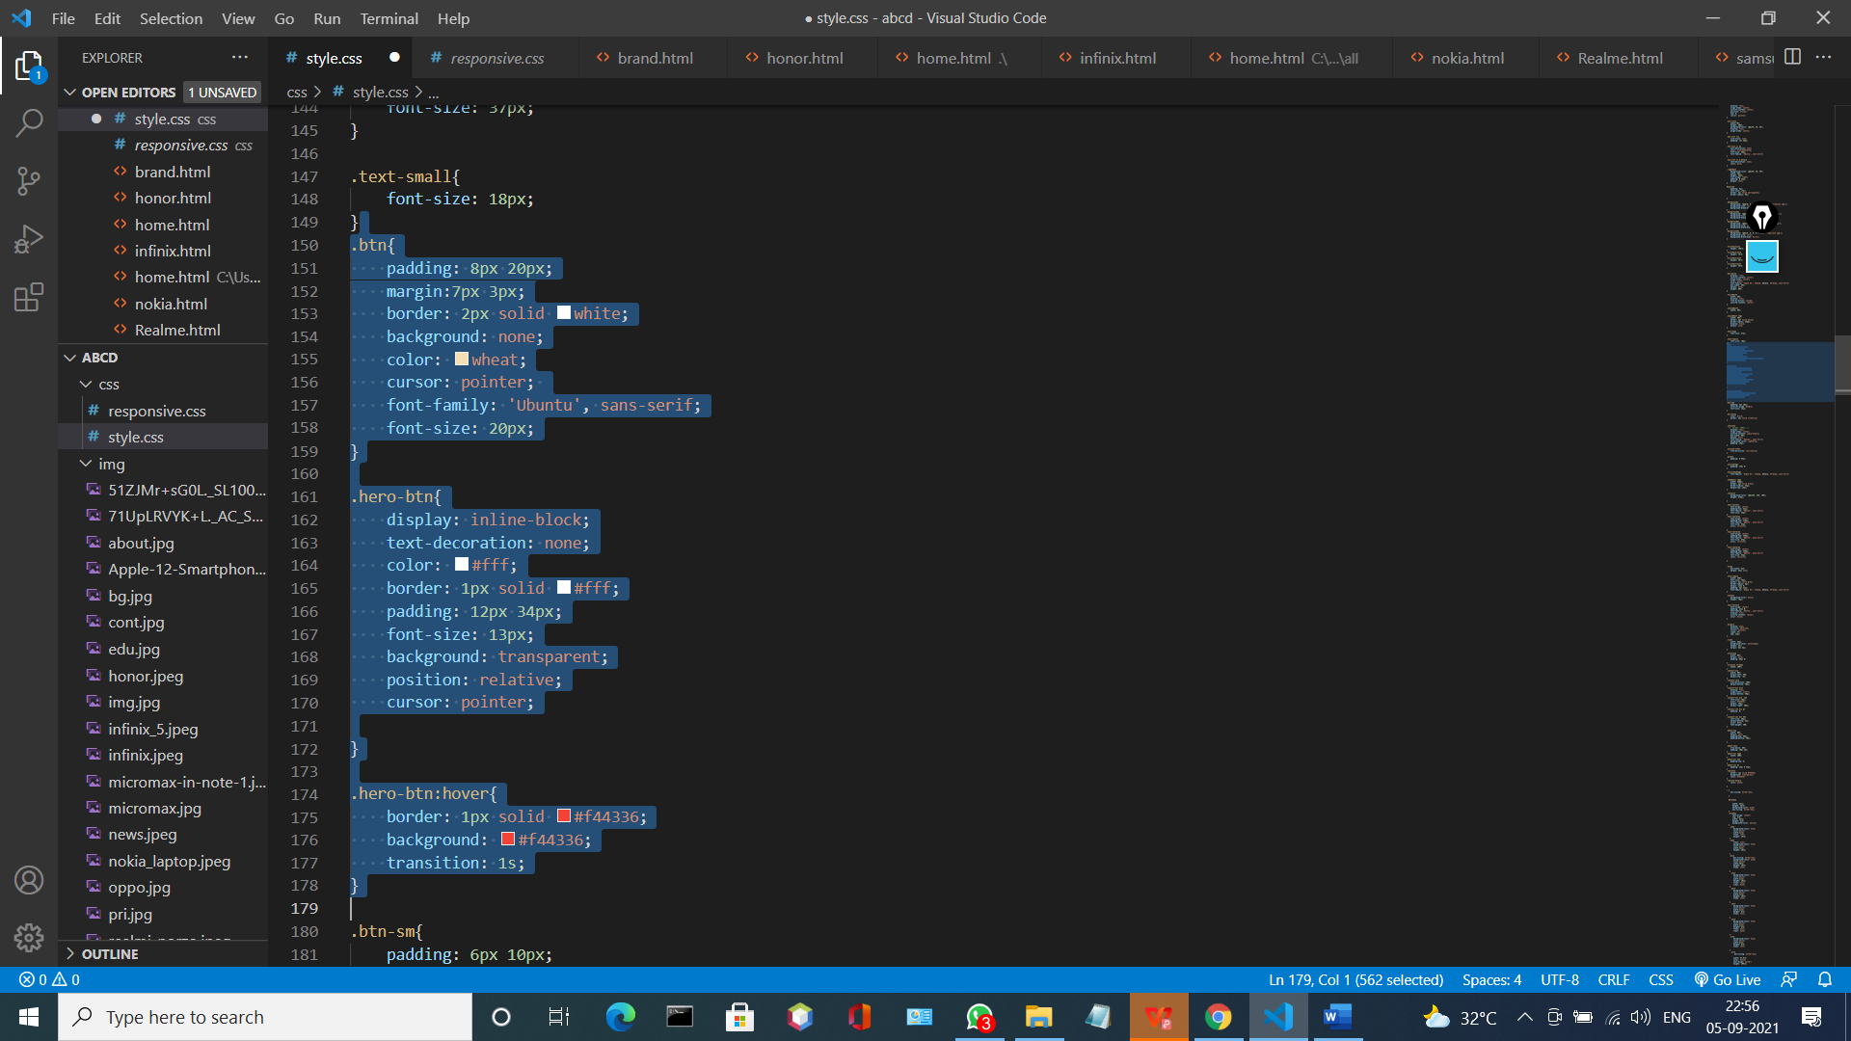

**OUTPUT:**

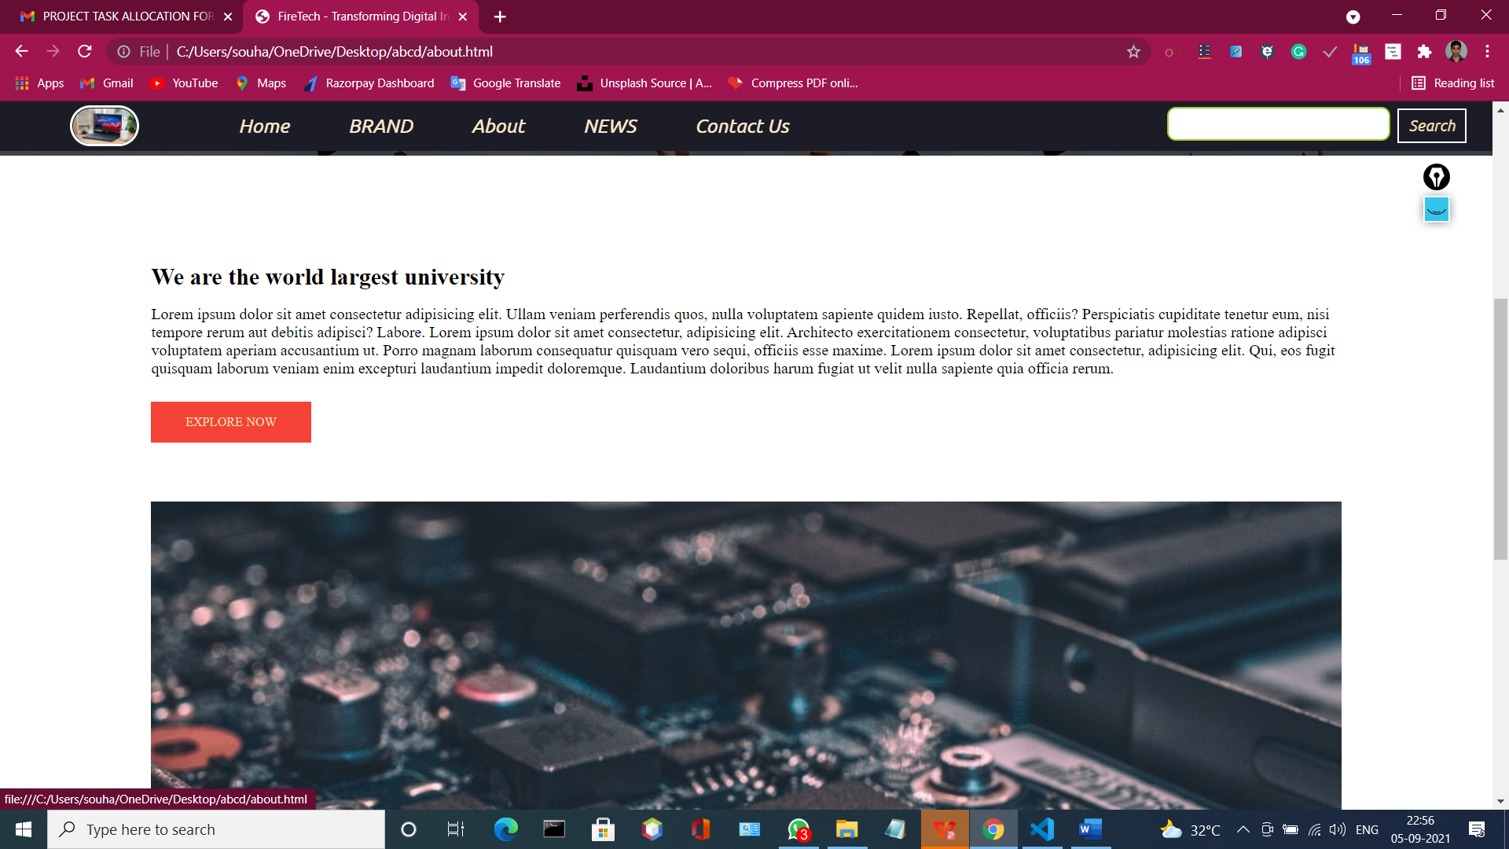

**News.html**

It will be same like home page and the .html code is

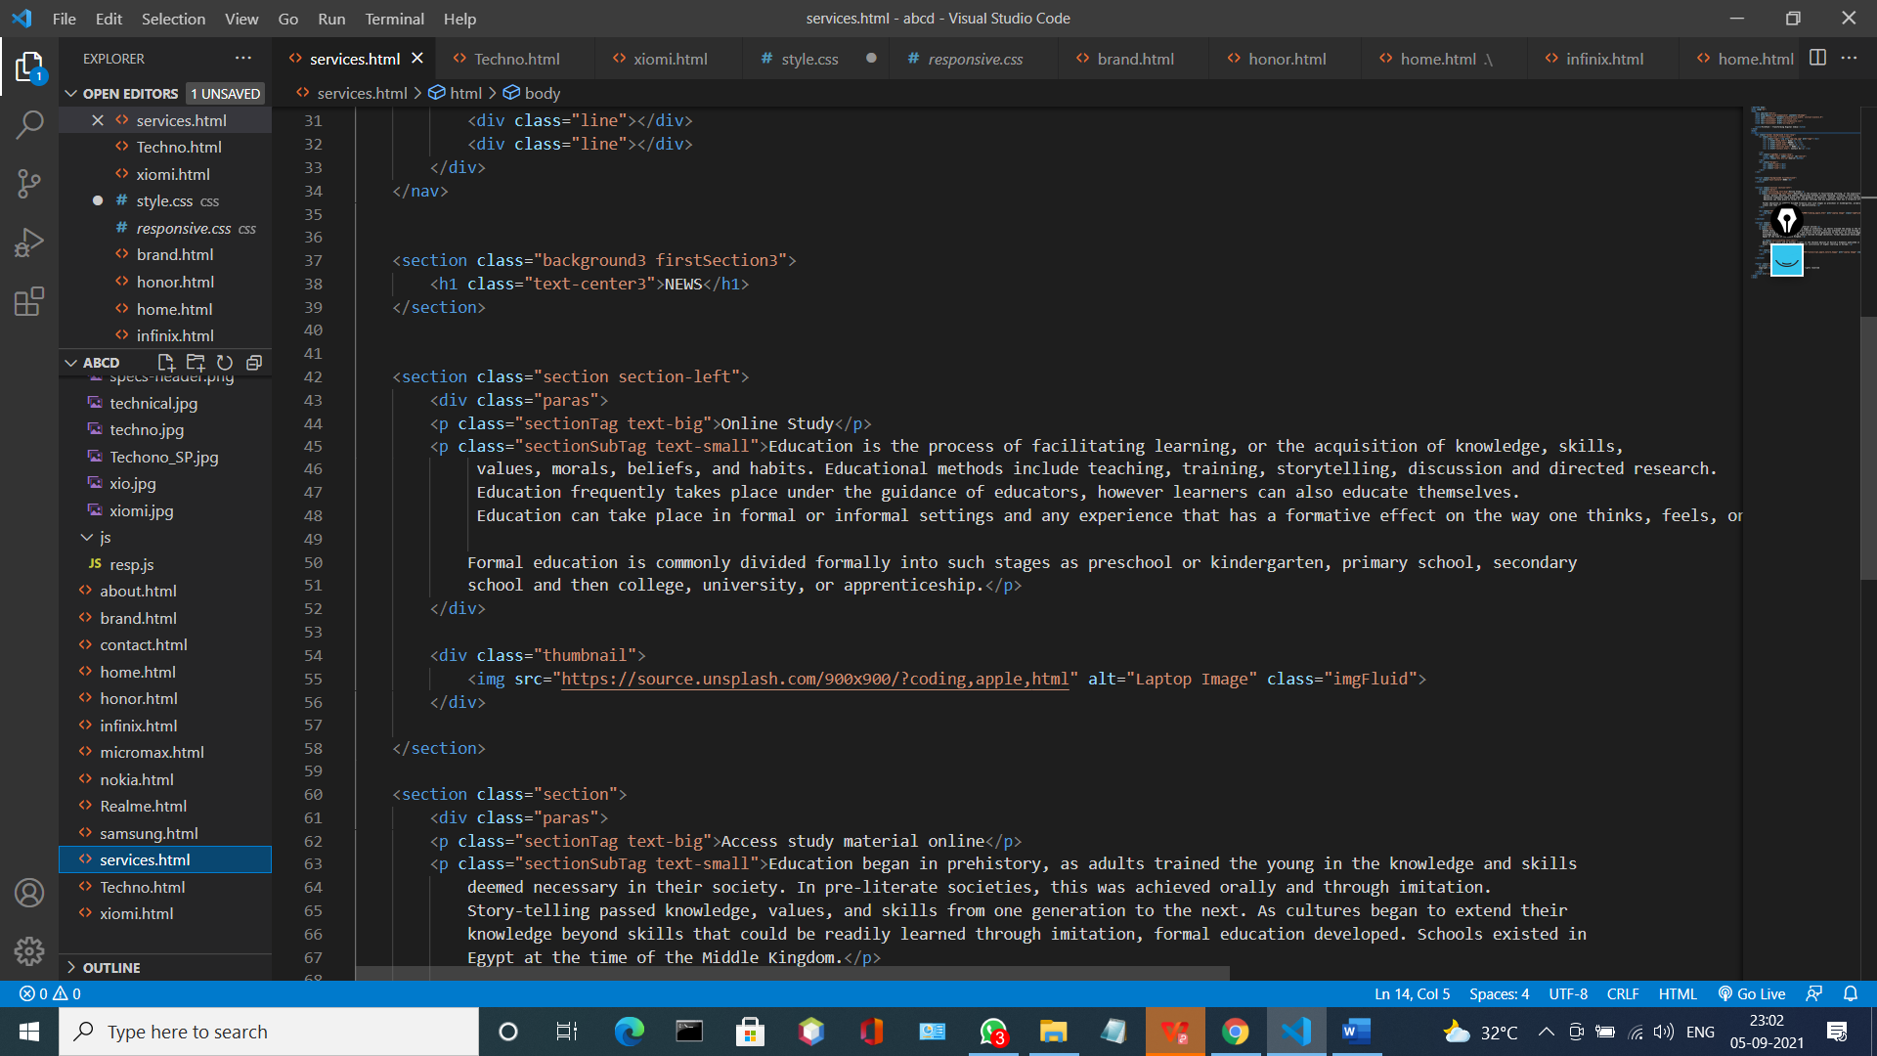

**OUTPUT:**

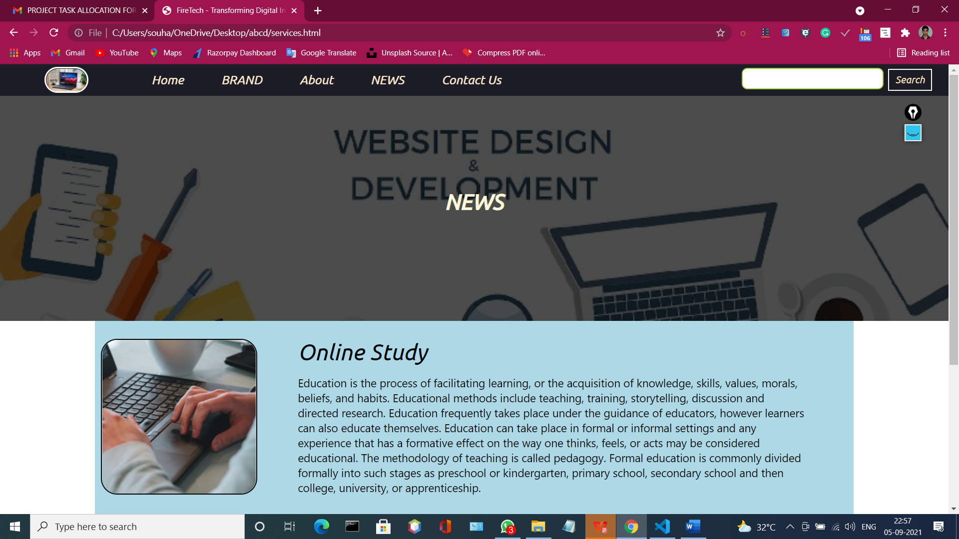

**Contact Us :**

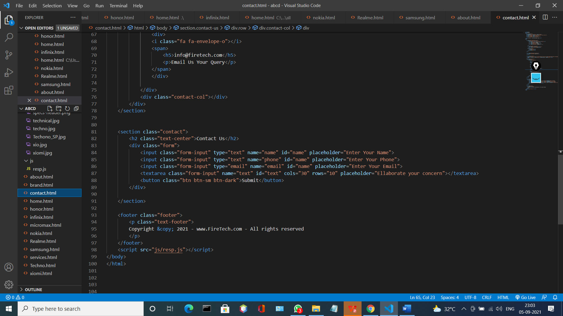

**Explanation:-**

Here we are add the placeholder for giving the input here we also create a Text area field also and also submit button and we also make this page responsive.

**OUTPUT:**

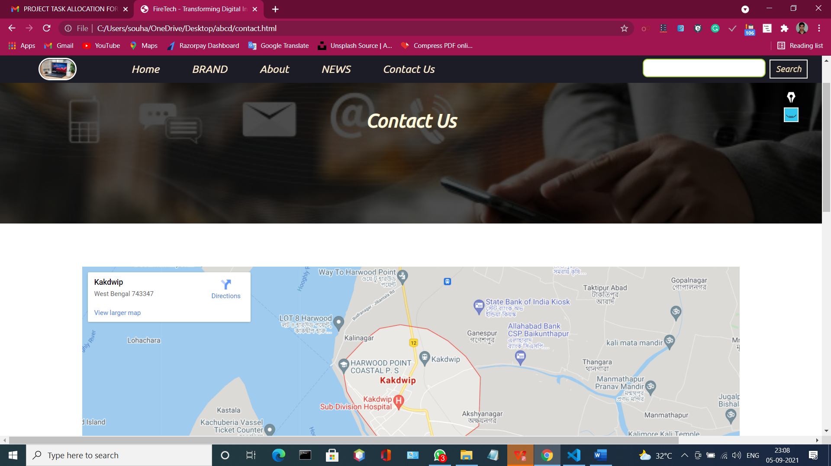

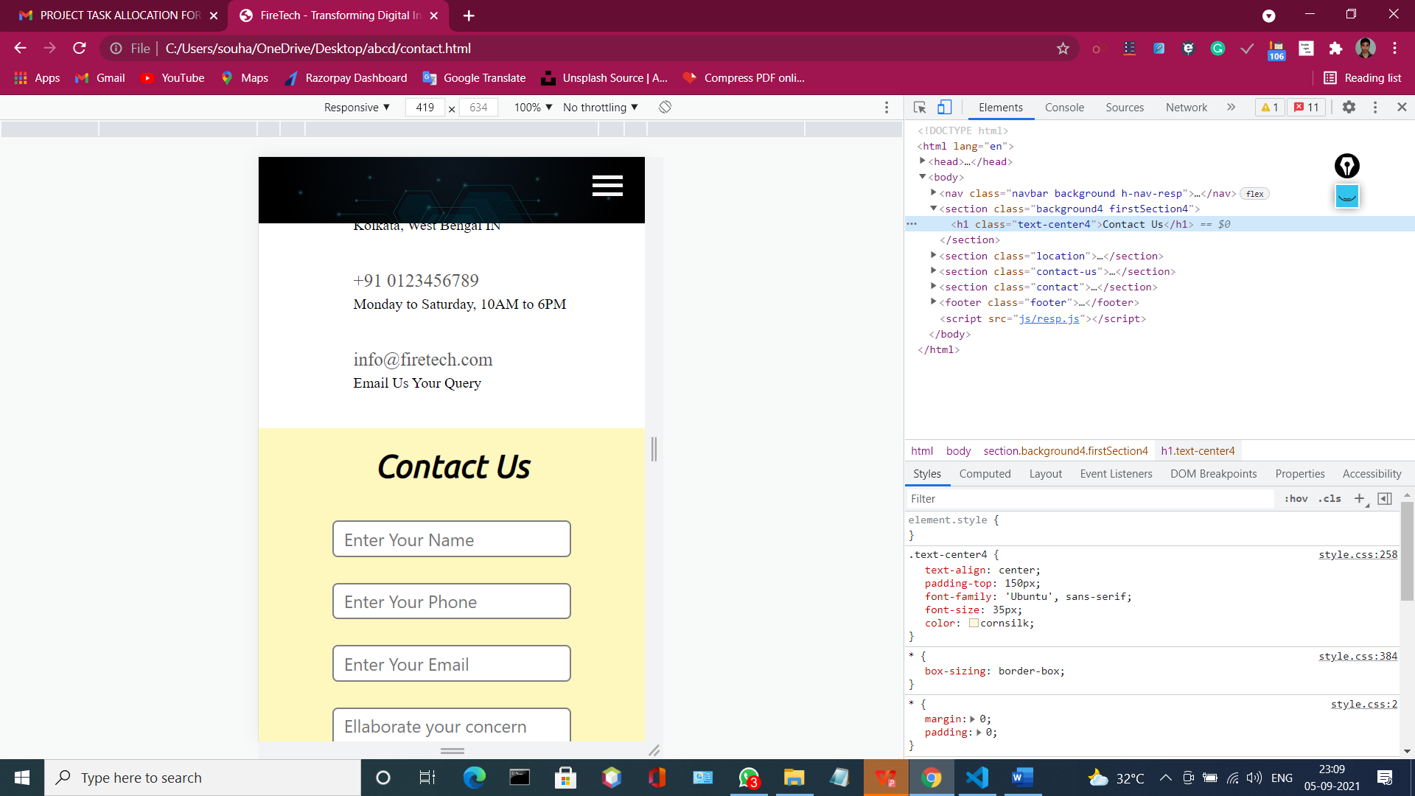

## 9. Conclusion

It has been and always be challenging to keep your website design up to different device sizes and resolutions. A responsive website, if developed properly, adapts to different device sizes, enhances user experience, is mobile-friendly, and is ready for future devices. This all has been possible due to three basic building blocks of Responsive Web Design (RWD) i.e. media queries, flexible/ scalable media (images and videos), and most importantly fluid/ flexible grids. Heavy websites posed constrains to mobile devices due to lesser capabilities of mobile web browsers as compared to those of desktop browsers. A fourth major building block was then added to RWD namely dynamic content which provides techniques like lazy loading and selective content loading. Dynamic content requires a properly structured semantic web content which itself requires a tedious work of document structuring and developing hierarchy of the content in correlation to the structure.

We have ready-made Responsive Frameworks to help developers just take care of their content structuring and hierarchical planning and forgot about the underlying tedious work of RWD principles. Selection of any such framework depends on user needs and requirements. Therefore, it is at the developer’s part to come up with the decision on which framework suits best for their website and this is the most important thing because to change the choice of framework in the middle or after the development means to start a new web project. Experienced developers and designers could also design their own responsive framework if required. Moreover, a responsive website requires on the go device agnostic testing during development phase and before actual launch to avoid later complications. Even ready-made frameworks could put the developers in a situation of chaos if handled improperly.

So far, RWD means a website which is able to adapt itself on various screen sizes and resolutions. We should have to take our responsive websites a step forward towards a responsive philosophy by which a website would not only adapt to different screen sizes but also adapt its content to suite different contexts of user behavior or user needs. In a nutshell, those days are not far away when Responsive Web Design with Responsive Philosophy would be declared a standard for websites as we have seen Google rating websites in their search results based on mobile-friendly test and in future it would rate websites as human-friendly, websites which would layout and shape their content based on user preferences, user behavior, location, age, gender and cultural values.

## References

1. B. Sanou, “International Telecommunication Union, ICT Facts and Figures 2014.”ITU ICT Statistics, May 2014. http://www.itu.int.
2. C. Sharkie and A. Fisher, *Jump Start Responsive Web Design*. Sitepoint, 2013.
3. M. Ethan, “Responsive Web Design.” Alistapart, May 2010. http://goo.gl/ arO06J.
4. J. Sanchez, “2013 the Year of Responsive Web Design.” Uberflip Infographic, December 2012. http://goo.gl/Z9YoZ5.
5. R. Belisle, “The Year of Responsive Web Design: Making your Website Mobile in2013,” March 2013. http://goo.gl/k84jxH.
6. “W3schools.” http://www.w3schools.com.
7. G. Candrlic, “How Website Speed Affects Conversion Rates,” December 2012. http://goo.gl/xRh7PM.
8. K. Scott, “A Pixel Identity Crisis.” Alistapart, January 2012. http://goo.gl/ hnFBez.
9. D. Storey, “Understanding Pixel Density, Resolution and Retina Displays.” Demosthenes.info Blog, August 2012. http://goo.gl/OxxSv4.
10. R. Frederick, “Not That Close! Avoiding the Landscape Zoom-in Effect on Mobile.”Fuseinteractive.ca Blog, September 2013. http://goo.gl/SpMFHu.
11. C. Mills, “Media Query Syntax Basics.” Peachpit.com Articles, July 2010. http:

//goo.gl/GvRyQG.

1. H. Pickering, “The Importance of HTML5 Sectioning Elements.” Smashing Magazine, January 2013. http://goo.gl/qxG5KC.
2. “W3C HTML5 Semantic Elements.” http://goo.gl/mB24IW.
3. “Build Faster WordPress Sites with Lazy Loading.” Creativebloq Blog, January

2015. http://goo.gl/qbKkda.

1. “What are Frameworks? 22 Best Responsive CSS Frameworks for Web Design.”

Awwwards.com Blog. http://goo.gl/Ks6TDC.

1. “What is Bootstrap? We Have the Answers.” Bootstrapbay.com Blog. http:// goo.gl/1zSKGo.
2. “Bootstrap components.” http://getbootstrap.com/components/.
3. “Helping Users Find Mobile-friendly Pages.” Google Webmaster Blogpost, November 2014. http://goo.gl/LGnwTW.
4. D. Gardner and M. Treff, “The Next Big Thing in Responsive Design.” Fastcodesign Blogs, September 2014. http://goo.gl/rvii9x.

1. Estimated
2. See figure-2, width of the row i.e. wrapper is 880px which will serve as the context value for rest of calculations
3.